



**DEPARTMENT OF COMPUTER SCIENCE AND ENGINEERING**

**A Project Report On**

“Track N Go: Innovative Real Time Bus Tracking and Arrival Prediction for Public and Private Sectors using Firebase.”

### A dissertation submitted to the Department of Computer Science and Engineering of Visvesvaraya Technological University in partial fulfilment for the award of the Degree of Bachelor of Engineering.

***Submitted By***

**SHAIK MOHAMMED NAVEED 3BR20CS155**

**SUHAIL AHMED 3BR20CS163**

**MAHIKA DHAR M 3BR20CS096**

**UTKARSH KUMAR 3BR20CS173**

**Under the Guidance of**

**Mr. Mohammed Shafiulla**

**Assistant Professor Dept of CSE BITM, Ballari.**



[**Visvesvaraya Technological University**](http://www.vtu.ac.in/)

**Belagavi, Karnataka**

**2023-2024**





**DEPARTMENT OF COMPUTER SCIENCE AND ENGINEERING**

# CERTIFICATE

This is to certify that the project work entitled **“**Track N Go: Innovative Real Time Bus Tracking and Arrival Prediction for Public and Private Sectors using Firebase.**”** is a bonafide work carried out by **SHAIK MOHAMMED NAVEED, SUHAIL AHMED, MAHIKA DHAR M, UTKARSH KUMAR** in partial fulfillment for the award of degree of Bachelor of Engineering in Computer Science and Engineering in the Visvesvaraya Technological University, Belagavi during the year 2023-2024. It is certified that all corrections and suggestions indicated for internal assessment have been incorporated in the report deposited in the library. The project has been approved as it satisfies the academic requirements in respect of project work prescribed for a Bachelor of Engineering degree.

|  |  |  |
| --- | --- | --- |
| Signature of Project Guide | Signature of HOD | Signature of Principal |
| **Mr. Mohammed Shafiulla** | **Dr. R. N. Kulkarni** | **Dr. Yadavalli Basavaraj** |

**External Viva**

**Name of the Examiner: Signature with Date 1.**

**2.**

**ACKNOWLEDGEMENT**

We express our warm and profound sense of gratitude to all the eminent faculties who inspired, guided and supported us in accomplishing our project work.

We are deeply indebted to **Mr. MOHAMMED SHAFIULLA**, Department of CSE, our guide on this project & coordinator **Dr. C K SRINIVAS,** on this project, for consistently providing us with the required guidance to help us in the timely and successful completion of this project. Despite his hectic schedules in the Department, he was always available to share his deep insights, wide knowledge, and extensive experience with us.

We are much obliged to our honorable Head of the Department **Dr. R. N. Kulkarni** for understanding the capability in us to complete the project successfully and, we are thankful to him for encouraging us and being a motivation and inspiration for us.

We extend our warm thanks to our Principal **Dr. Yadavalli Basavaraj** for giving us moral support and providing us all kinds of facilities.

We also thank all the faculty members of our department for being with us when needed. Last but not least we also thank our beloved friends who were there with us all the time, supporting, providing assistance, and giving us enough strength to successfully complete our project, proving the popular saying, “A Friend in need is a Friend indeed” to be true.

**NAME USN**

**SHAIK MOHAMMED NAVEED 3BR20CS155 SUHAIL AHMED 3BR20CS163 MAHIKA DHAR M 3BR20CS096 UTKARSH KUMAR 3BR20CS173**

# ABSTRACT

Public transport systems often face challenges related to reliability and efficiency, leading to inconvenience and uncertainty for passengers. Existing solutions for real-time bus monitoring typically rely on expensive Internet of Things (IoT) components. This paper presents Track N Go, a cost-effective alternative for real-time monitoring of public buses and taxis using mobile phone location data. The system utilizes a robust backend system built with Java and React.Js for the user interface. Integration of GPS via the Map Box API and Firebase database ensures accurate location tracking. Track N Go provides accurate real-time monitoring, addressing challenges associated with public transport and improving overall urban mobility. The system enhances convenience and peace of mind for passengers by delivering reliable and user-centric solutions. The evaluation of Track N Go demonstrates its effectiveness in improving urban mobility and transit services. By offering a reliable and cost-effective solution for real-time bus monitoring, Track N Go aims to streamline daily commutes and make public transport more efficient and predictable.

|  |  |  |
| --- | --- | --- |
| **Table of Contents** | | |
| **Chapter No** | **Chapter Name** | **Page No** |
|  | Acknowledgement |  |
|  | Abstract |  |
| 1 | Introduction | 7 |
| 2 | Literature Survey | 10 |
| 3 | Requirements Specifications | 18 |
| 4 | System Design | 20 |
| 5 | Implementation | 26 |
| 6 | System Testing | 36 |
| 7 | Results and discussion | 40 |
| 8 | Conclusion and future scope | 51 |
| 9 | References | 52 |
|  |  |  |

|  |  |  |
| --- | --- | --- |
| **List of Tables** | | |
| **Table No** | **Table Name** | **Page No** |
| 6.1 | Unit Testing | 37 |
|  |  |  |

|  |  |  |
| --- | --- | --- |
| **List of Figures** | | |
| **Figure No** | **Figure Name** | **Page No** |
| 7.1 | Homepage and User Login page to allow users to authenticate | 40 |
| 7.2 | Admin Login Page (Main admin, Organization head and  Officer Login) | 40 |
| 7.3 | Admin dashboard page. Display various statistics about  the queues and tokens. | 41 |
| 7.4 | Add an organization page. Fill in the form to create an organization. | 42 |
| 7.5 | Organization list page. View all organizations and provide.  buttons to edit or delete the organization. | 42 |
| 7.6 | Add a counter page. Fill in the form to create a counter in an organization. | 43 |
| 7.7 | Counter list page. Display all the counters with buttons to  edit or delete them. | 44 |
| 7.8 | Add user page. Fill in the form to create a user (User type:  Org Head, Officer, Client User) | 45 |
| 7.9 | User list page. Display all the users with buttons to edit or delete them. | 46 |
| 7.10 | Issue token page (Admin) | 47 |
| 7.11 | Queue display page. Displays pending and currently serving tokens in a counter. | 47 |
| 7.12 | Issue token page (Client). Click on any desired counter to join its queue. | 48 |
| 7.13 | Print token page (Client). View token details and provide option to print it | 48 |
| 7.14 | User dashboard page. View analytics related to token transactions done by the user. | 49 |
| 7.15 | Fig 7.15 User report page. View detailed report of the token transactions done by the user. | 50 |
|  |  |  |

# CHAPTER 1

# INTRODUCTION

## OVERVIEW

In the realm of urban living, optimizing public transportation stands as a crucial element for ensuring smooth commuting experiences. However, traditional bus tracking methods pose complex challenges with their costly and intricate IoT-based implementations. Recognizing these hurdles, "Track N Go" introduces a disruptive solution leveraging mobile phones for real-time bus tracking. By democratizing this technology, Track N Go not only reduces operational costs but also enhances accessibility across public and private sectors. Rooted in a commitment to improve commuters' journey experiences, the project aims for inclusivity, cost-effectiveness, and user-centricity. Through innovative mobile technology, Track N Go addresses immediate tracking needs while paving the way for future urban mobility advancements. It sets objectives to confront traditional tracking challenges with a scalable, user-friendly alternative, enriching public transit reliability and efficiency. The project's significant contribution lies in its mobile-centric approach, revolutionizing bus tracking without complex IoT setups. This concise introduction encapsulates Track N Go's commitment to innovation, efficiency, and the continual enhancement of urban mobility.

## EXISTING SYSTEM

In the realm of urban living, optimizing public transportation stands as a crucial element for ensuring smooth commuting experiences. However, traditional bus tracking methods pose complex challenges with their costly and intricate IoT-based implementations. Recognizing these hurdles, "Track N Go" introduces a disruptive solution leveraging mobile phones for real-time bus tracking. By democratizing this technology, Track N Go not only reduces operational costs but also enhances accessibility across public and private sectors. Rooted in a commitment to improve commuters' journey experiences, the project aims for inclusivity, cost-effectiveness, and user-centricity. Through innovative mobile technology, Track N Go addresses immediate tracking needs while paving the way for future urban mobility advancements. It sets objectives to confront traditional tracking challenges with a scalable, user-friendly alternative, enriching public transit reliability and efficiency. The project's significant contribution lies in its mobile-centric approach, revolutionizing bus tracking without complex IoT setups. This concise introduction encapsulates Track N Go's commitment to innovation, efficiency, and the continual enhancement of urban mobility.

#### Disadvantages:

1. Existing bus tracking systems entail high infrastructure costs, hindering widespread adoption.
2. Limited scalability is a drawback of traditional systems, constraining their ability to accommodate growing demand.
3. Complex user interfaces in existing systems lead to usability issues for administrators and commuters alike.

## PROPOSED SYSTEM

The proposed system, "Track N Go," introduces a novel real-time bus monitoring solution aimed at enhancing public transportation services. Unlike traditional methods that rely on expensive IoT components, Track N Go leverages mobile phone location data to offer a cost-effective and scalable alternative. The system's architecture includes a robust backend developed with Java, a user-friendly interface built on React.js, and integration of GPS via the Map Box API. Firebase serves as the database for real-time storage of driver location coordinates. The system's objectives include providing accurate and real-time bus tracking, creating user-friendly interfaces for administrators and commuters, offering a cost-effective tracking solution, and minimizing reliance on IoT components to reduce costs while maintaining security.

#### Advantages:

1. Cost-effective real-time bus tracking solution using mobile phone location data.
2. Scalable system architecture capable of meeting increasing demands without compromising performance.
3. User-friendly interfaces for both administrators and commuters, enhancing accessibility and usability.

## OBJECTIVES

* + - To provide an accurate and real-time bus tracking system.
    - To create user-friendly interfaces for admins and commuters, improving productivity and convenience.
    - To offer a cost-effective real-time tracking solution.
    - To minimize the reliance on IoT components and reduce costs while maintaining security.
    - To provide user friendly queries and communication between user and Administrator.

## VISION AND MISSION

### VISION

To enhance the public transportation experience, introduce cashless ticket purchasing and user-friendly navigation. Streamline vehicle oversight for efficiency and integrate cutting-edge traffic management solutions to minimize congestion and delays, ensuring a smoother, stress-free journey for all travelers.

### MISSION

* To eliminate the guesswork and provide precise bus arrival times.
* To ensure effortless navigation for both commuters and administrators.
* To streamline vehicle registration and management for administrators and organizations

## PROBLEM STATEMENT AND SCOPE OF THE PROJECT

### PROBLEM STATEMENT

To develop a GPS-based system, revolutionizing vehicle tracking for public and private sectors, and enhancing commuting experiences with real-time updates.

### SCOPE OF THE PROJECT

The project entails the development and implementation of a comprehensive transportation management system customized for the Ballari Institute of Technology and Management, initially focusing on private institutions. Operating within the college campus, the system will provide real-time bus tracking, precise arrival times, and route information, prioritizing data security exclusively for administrators. Employing cost-effective mobile phone location tracking, the design emphasizes scalability and future expansion, envisioning integration with the Ballari depo in the government sector. Future capabilities include predicting passenger crowds, enabling proactive bus allocation, and anticipating traffic on festival days. The project integrates with Map Box API to enhance user experience with location-based services. Safety features encompass text and pop-up notifications for driver location issues. overarching vision is to establish a seamless and efficient transportation system within the college, serving as a pilot project for potential collaboration with government sectors, such as the government depot, fostering cooperation and enhancing commuting convenience for the public.

**CHAPTER 2**

# LITERATURE SURVEY

## Android based energy aware real-time location tracking system (Y. Ozen, O. Ozdemir and N. Bandirmali)

The emphasis on real-time tracking presented in this paper perfectly aligns with the project’s objectives. Anyone can incorporate the concept of continuous real-time monitoring to track the bus by leveraging data from the driver and conductor's locations. By doing so, it can provide users with up-to-the-minute information on the bus's current location. Additionally, the paper employs a client-server model for tracking and monitoring. While the paper's context is healthcare-related, it can readily adapt this model to project. In this adaptation, the driver and conductor will serve as clients, providing essential location data, while the server will handle the processing and display of this data for efficient bus tracking. Furthermore, if a project entails the development of an Android app, it can draw valuable insights from the methods and techniques discussed in the paper related to Android application development. This will aid us in creating a more robust and feature- rich application for the project’s specific needs.

**Insights**: Continuous real-time monitoring leveraging driver and conductor location data can provide users with up-to-the-minute bus location information, aligning with Track N Go's objectives.

## Design and implementation of real time vehicle monitoring, tracking, and controlling system (P. Jyothi and G. Harish)

This paper discusses the use of PWM pulses for controlling vehicle speed. Although the project’s primary focus may not be speed control, it can adapt the speed monitoring components to send alerts to the server if the bus exceeds predefined speed limits. This adaptation will contribute to promoting safe driving practices. Additionally, the paper features safety elements like temperature sensors and gas leakage sensors. It can seamlessly integrate these sensors into the project to enhance passenger safety and continuously monitor the bus's operational condition. Furthermore, the paper employs alert messages for notifying the vehicle owner about various conditions, such as speeding and deviations from the intended route. It can implement similar alert mechanisms to keep relevant stakeholders well-informed about the bus's status. Lastly, this paper emphasizes the remote control and tracking of vehicles. While the project may not center on remote control, the capability to monitor and track the bus's location through mobile devices aligns perfectly with the project’s objectives, ensuring real-time awareness of the vehicle's whereabouts.

**Insights:** The integration of speed monitoring components for alerting if the bus exceeds speed limits enhances safety practices in Track N Go.

## Real-time GPS tracking using serverless architecture and ARM processor (S. Anand, A. Johnson, P. Mathikshara and R. Karthik)

The paper underscores the use of a serverless architecture for efficient data processing and management. To implement this in a project, it can explore serverless platforms like AWS Lambda, Google Cloud Functions, or Azure Functions. These platforms will allow us to process location data from drivers and conductors in real-time, efficiently handling data without the need for managing traditional server infrastructure. In line with the data acquisition and filtering techniques presented in the paper, it is essential to extract relevant information from NMEA strings received from GPS modules. Anyone can achieve this by implementing regular expressions or other parsing methods to effectively extract latitude and longitude coordinates. Moreover, the paper discusses the use of NoSQL databases for fast data storage and retrieval. Consider integrating a cloud-based NoSQL database, such as Amazon DynamoDB or Google Cloud Fire store, for storing location data from bus tracking system. These databases are well-suited for handling real-time data and ensuring efficient data management. To enhance the security and alert capabilities of tracking systems, it's beneficial to implement geofencing. This feature can send email notifications when a vehicle moves outside a specific geographical boundary, and it should be customizable based on user preferences. Geofencing not only boosts security but also offers a valuable way to keep track of vehicles.

This geofenced area is feature provides an extra layer of security and ensures that relevant parties are promptly notified of any deviations from the established boundaries. Lastly, the user interface is a key component of a project. Design a user-friendly web interface accessible from both mobile and desktop devices. Ensure that the interface offers all the necessary features for tracking and monitoring vehicles, making it convenient and effective for users to interact with the system.

**Insights:** Implementing a serverless architecture using platforms like AWS Lambda or Google Cloud Functions can efficiently process real-time location data in Track N Go.

## A Vehicle Tracking System Using Greedy Forwarding Algorithms for Public Transportation in Urban Arterial (O. D. Jimoh, L. A. Ajao, O. O. Adeleke and S. S. Kolo)

The system integrates GPS and GSM modules for tracking vehicle locations and transmitting data wirelessly to a central server. The central control unit for processing activities in the tracking system is an Atmega328P controller chip. For monitoring and displaying vehicle positions, the system incorporates Google Maps integration, offering a user-friendly interface. To determine vehicle locations, the system utilizes a GPS- based greedy forwarding algorithm. It also calculates route distance information using a distance-time-based algorithm. For precise location determination during signal transmission from GPS satellites to the receiver module, the system employs a pseudo-range mathematical model, specifically the Haversine formula. Additionally, the system employs the "minimum inversion matrix" method for GPS-based Geometric Dilution of Precision (GDOP) selection of satellite approximation and distance, contributing to location accuracy. The system's application extends to enhancing fleet management for urban arterial public transportation, making it a potentially valuable solution for universal adoption.

**Insights:** Integrating GPS and GSM modules for wireless data transmission and employing algorithms like the Haversine formula ensures accurate real-time bus tracking in Track N Go.

## Design and Business Modelling of an IoT Based Cost-Effective Vehicular Monitoring System for Next Generation Smart Vehicle (M. S. A. khan, T. Akter, M. M. Y. Hossain, M. S. Hossain, S. Mazumder, and M. K. Alam)

The paper emphasizes the importance of cost-effective solutions for smart vehicles. It discusses the design of a low-cost monitoring system that includes features like temperature-based fan control, coolant/water level detection, engine oil level detection, and engine temperature detection. The system offers real-time monitoring of critical parameters such as engine temperature, coolant level, and fan speed. This real-time monitoring can enhance vehicle safety and efficiency. The paper also presents the implementation of a vehicle tracking system using GPS and GPRS technology. It includes a smartphone application for tracking vehicle locations on a map. The research provides a cost comparison between the proposed system and existing market offerings. The proposed system's price is found to be lower than the market price, making it a cost-effective solution. The paper includes a business model for the proposed system, which can be valuable for understanding the commercial aspects of the project.

**Insights:** Implementing cost-effective real-time monitoring of critical parameters, coupled with GPS tracking via smartphone application, enhances safety and efficiency in Track N Go.

## A Real-Time Motion Based Fuel Monitoring Technique for Vehicle Tracking Systems (F. Farzana, M. M. Hossain, M. M. Imtiaze, M. T. Hossain)

The research paper stresses the importance of incorporating motion parameters like orientation, acceleration, and vibration into the tracking device to enhance the precision of fuel level measurements. In the project, can follow this lead by integrating similar motion data, improving the accuracy of bus tracking and arrival predictions. Additionally, the paper showcases the development of a smartphone application for real-time fuel data observation. Drawing inspiration from this, It can create a user-friendly mobile app for real-time bus tracking, aligning with goal to offer commuters a seamless experience. The paper also provides methods for detecting suspicious activities, such as fuel theft and leaks. Implementing features in the project to identify unusual events or disruptions in bus schedules can enhance reliability and security for public transportation users. Furthermore, the paper discusses data filtering and analysis techniques, which we can apply to refine and analyze location data from buses, ensuring more accurate predictions and tracking. Lastly, it highlights the correlation between motion parameters and fuel status. In the project, consider conducting correlation analysis between bus movement data and arrival times to offer more precise predictions and real- time tracking. The paper's mention of a success rate can serve as a benchmark to assess the accuracy and reliability of the bus tracking system.

## Tracking, Arrival Time Estimator, and Passenger Information System on Bus Rapid Transit (BRT) (M. A. Hafiizh Nur, S. Hadiyoso, F. B. Belladina, D. N. Ramadan and I. Wijayanto)

The paper discusses the development of an integrated online system for the Bus Rapid Transit (BRT) system in Bandung, Indonesia. The primary objective of this system is to provide real-time information to passengers, including bus arrival times, bus positions, and the number of passengers on board. This integrated system employs various hardware components, such as GPS modules for bus tracking and infrared detectors to count passengers. The collected data is then transmitted to a Firebase real-time database for synchronization and real-time access. The research highlights the significance of public transportation in urban areas and identifies the lack of comprehensive information systems for BRT passengers. By integrating IoT technology and real-time databases, the system aims to enhance the overall BRT service quality by enabling passengers to access critical information for trip planning, including estimated bus arrival times and real-time bus positions. The paper also presents testing results, indicating that the system's data transmission and passenger counting are highly accurate. The use of GPS modules results in an average location accuracy of 5.36 meters. In summary, this research introduces an innovative solution to address the information gaps in BRT systems, improving the passenger experience and overall service quality.

**Insights**: Incorporating motion data for enhanced tracking accuracy and developing a user-friendly mobile app for real-time bus tracking can significantly improve commuter experience in Track N Go.

## A Real-time School Bus Tracking and Monitoring System (K. Ammar, M. Jalmoud, A. Boushehri and K. Fakhro)

The paper delves into the development of a real-time school bus tracking and monitoring system designed to enhance the safety and convenience of school transportation. School bus safety is a paramount concern due to various issues such as students mistakenly boarding the wrong buses, being dropped off at incorrect locations, and, tragically, incidents involving students being inadvertently left locked inside school buses. Existing solutions have employed a range of technologies including GPS, RFID, and SMS to address specific aspects of school bus tracking and monitoring. Several proposed systems in the literature have focused on various features, such as monitoring loading and unloading activities, sending SMS alerts to parents, tracking the real-time location of school buses, issuing notifications for deviations from assigned routes or speeding buses, and offering amenities like next-stop alerts and accident notifications. The paper introduces a highly automated system comprised of an on-board tracking unit and a tracking server unit. The on-board tracking unit gathers data from GPS, RFID readers, and various sensors and communicates this data to the tracking server using GSM technology. The tracking server plays a crucial role in verifying and processing the collected data, providing services such as real-time bus tracking displayed on Google Maps, information on boarding and disembarking status of students, SMS notifications to parents, and generating attendance reports. This innovative system significantly mitigates the risk of students being inadvertently left inside the bus, assures that students board the correct bus, and offers proximity notifications to parents to keep them informed. Additionally, the system supports two-way phone communication between school authorities and bus drivers and can promptly send emergency alerts when necessary. For future enhancements, the system could incorporate additional features, such as pollution and noise sensors to monitor the environment, temperature monitoring for student comfort, security cameras for enhanced safety, and the capability to detect heavy traffic routes for route optimization. This comprehensive approach to school bus tracking.

**Insights**: Implementing a comprehensive tracking system with GPS, RFID, and GSM technology can enhance safety and efficiency in tracking public transportation like buses, ensuring accurate location tracking and real-time notifications for passengers and stakeholder.

## A Vehicle Tracking System Using Greedy Forwarding Algorithms for Public Transportation in Urban Arterial (O. D. Jimoh, L. A. Ajao, O. O. Adeleke and S. S. Kolo)

The system integrates GPS and GSM modules for tracking vehicle locations and transmitting data wirelessly to a central server. The central control unit for processing activities in the tracking system is an Atmega328P controller chip. For monitoring and displaying vehicle positions, the system incorporates Google Maps integration, offering a user-friendly interface. To determine vehicle locations, the system utilizes a GPS- based greedy forwarding algorithm. It also calculates route distance information using a distance-time-based algorithm. For precise location determination during signal transmission from GPS satellites to the receiver module, the system employs a pseudo-range mathematical model, specifically the Haversine formula. Additionally, the system employs the "minimum inversion matrix" method for GPS-based Geometric Dilution of Precision (GDOP) selection of satellite approximation and distance, contributing to location accuracy. The system's application extends to enhancing fleet management for urban arterial public transportation, making it a potentially valuable solution for universal adoption.

**Insights:** Integrating GPS and GSM modules for wireless data transmission and employing algorithms like the Haversine formula ensures accurate real-time bus tracking in Track N Go.

## Design and Business Modelling of an IoT Based Cost-Effective Vehicular Monitoring System for Next Generation Smart Vehicle (M. S. A. khan, T. Akter, M. M. Y. Hossain, M. S. Hossain, S. Mazumder, and M. K. Alam)

The paper emphasizes the importance of cost-effective solutions for smart vehicles. It discusses the design of a low-cost monitoring system that includes features like temperature-based fan control, coolant/water level detection, engine oil level detection, and engine temperature detection. The system offers real-time monitoring of critical parameters such as engine temperature, coolant level, and fan speed. This real-time monitoring can enhance vehicle safety and efficiency. The paper also presents the implementation of a vehicle tracking system using GPS and GPRS technology. It includes a smartphone application for tracking vehicle locations on a map. The research provides a cost comparison between the proposed system and existing market offerings. The proposed system's price is found to be lower than the market price, making it a cost-effective solution. The paper includes a business model for the proposed system, which can be valuable for understanding the commercial aspects of the project.

**Insights:** Implementing cost-effective real-time monitoring of critical parameters, coupled with GPS tracking via smartphone application, enhances safety and efficiency in Track N Go.

## Real-time on-campus public transportation monitoring system (S. A. Saad, A. '. B. Hisham, M. H. I. Ishak, M. H. M. Fauzi, M. A. Baharudin and N. H. Idris)

The paper discusses the development of a real-time on-campus public transportation monitoring system, addressing the issue of inadequate bus arrival time, location, and occupancy information that deters commuters from using public transport. The system consists of a GPS-based tracking device on buses, a web application for user interface, and an estimated time of arrival (ETA) calculation. The tracking device continuously reports the bus's location and speed to a cloud database, enabling real-time updates. Users can access the web application, which displays bus routes, bus stop numbers, real-time bus locations on Google Maps, and estimated arrival times at bus stops. This system is designed to enhance user satisfaction and ridership, particularly among university students. Future work could involve improving ETA prediction accuracy through methods such as integrating filters and model-based prediction techniques.

**Insights:** Implementing a real-time bus tracking system with GPS-based devices and a user-friendly web interface can significantly improve commuter satisfaction and ridership by providing accurate bus location updates and estimated arrival times, particularly beneficial for university students.

**[12] Chittagong University Teachers’ Bus Tracking System Using Smartphone Application (Mohammad Shah Alamgir, Israt Jahan, Nasrin Aktar, Anika Nowshin Ramisa)**

This paper presents a novel real-time bus tracking system designed for Chittagong University (CU) teachers, utilizing smartphone applications. Recognizing the limitations of existing tracking systems, such as costly hardware maintenance and slow database update rates, the authors propose a solution that employs two smartphone apps and Firebase, an online server with real-time database capabilities. The system operates by collecting GPS data from satellites through an In-vehicle app, which then transmits this information to Firebase for rapid updating and forwarding to the User app. Users can access real-time bus location, distance to bus stops, and estimated time to reach destinations, offering a cost-effective, fast, and user-friendly alternative to conventional tracking systems. Testing demonstrates the system's efficacy, suggesting potential for wider implementation across CU's bus fleet.

**Insights**: Implementing a real-time bus tracking system using smartphone applications and Firebase for rapid data updates offers a cost-effective and user-friendly solution for providing commuters with accurate bus location information, enhancing overall user experience and system efficacy.

**[13] Real-time Cooperative Vehicle Tracking in VANETs (Taku Noguchi, Yu-Cheng Ting, Masami Yoshida, Alberto Gallegos Ramonet)**

The research paper proposes a cooperative method for real-time vehicle tracking in Vehicular Ad Hoc Networks (VANETs) to address challenges posed by unpredictable target vehicle movement and uneven participation of vehicles in the tracking process. By leveraging both vehicle-to-vehicle (V2V) and vehicle-to-infrastructure (V2I) communications, the method ensures uninterrupted tracking by having vehicles and roadside units (RSUs) cooperate in tracking the target vehicle's location. Unlike existing systems that rely on periodic broadcast transmissions, the proposed method utilizes a handoff request message to seamlessly transfer tracking responsibility between vehicles. Simulation results demonstrate the effectiveness and efficiency of the approach, highlighting its potential for enhancing traffic management, facilitating stolen car recovery, and reducing police pursuit-related accidents.

**Insights:** Implementing a cooperative tracking method using V2V and V2I communication can enhance the accuracy and efficiency of real-time bus tracking, ensuring uninterrupted monitoring even in scenarios of unpredictable bus movement and varying participation levels of buses in the tracking process, thereby improving overall traffic management and passenger safety.

**[14] A Real-Time Visual Tracking for Unmanned Aerial Vehicles with Dynamic Window (Jia Zhang1, TianrunChen, and ZhiguoShi)**

The paper presents DyWinSiam, a novel framework for real-time visual object tracking in Unmanned Aerial Vehicles (UAVs). Addressing the challenge of processing high-resolution UAV video sequences in real-time, DyWinSiam introduces a dynamic window selection strategy, significantly accelerating tracking without compromising accuracy. Comprising feature extraction and region proposal stages, DyWinSiam utilizes a convolutional neural network for feature extraction and a region proposal subnetwork for predicting target bounding boxes. Experimental evaluation on 61 high-resolution UAV video sequences demonstrates DyWinSiam’s superiority over state-of-the-art trackers, achieving a success rate of 79.03% at a remarkable speed of 98.78 frames per second (fps). Comparative analysis against SiamRPN and DaSiamRPN reveals DyWinSiam’s substantial speed increase of 3.92 and 1.78 times, respectively, while maintaining competitive accuracy. DyWinSiam emerges as an efficient solution for real-time visual tracking in UAV applications, offering a balance between speed and precision crucial for high-resolution video sequences.

**Insights:** Implementing DyWinSiam's dynamic window selection strategy could significantly accelerate real-time bus tracking from high-resolution video feeds, enhancing tracking speed without sacrificing accuracy, thereby improving the efficiency of surveillance and monitoring systems for public transportation.

**CHAPTER 3**

**REQUIREMENT SPECIFICATION**

Requirement analysis is a very critical process that enables the success of a system or software project to be assessed.

## SYSTEM REQUIREMENTS

### HARDWARE REQUIREMENTS

* Processor - Any processor with a base frequency of 1.8 GHz.
* RAM - Minimum-2GB; Preferable-4GB.
* Hard disk - 128 GB (for OS and Software).

### SOFTWARE REQUIREMENTS

* OS - Windows 7 and above, Linux, MacOS.
* Front-end design - JS, ReactJS, CSS3, HTML5.
* Back-end design - Java.
* Data Base - Google Firebase.
* Map API - Map Box API

## FUNCTIONAL REQUIREMENTS

Track N Go aims to provide a seamless and efficient bus tracking experience for both administrators and commuters. The system should allow administrators to manage bus routes, schedules, and user accounts effectively. For commuters, it should offer real-time bus location tracking, accurate arrival time estimation, and user-friendly interfaces for journey planning. Additionally, the system should support notifications for bus arrivals and departures, allow users to save favourite routes, and provide options for reporting issues or feedback.

1. Bus route management for administrators.
2. Bus schedule management for administrators.
3. User account management for administrators.
4. Real-time bus location tracking for commuters.
5. User-friendly interfaces for journey planning for commuters.

## NON-FUNCTIONAL REQUIREMENTS

In addition to its functional capabilities, Track N Go must adhere to various non-functional requirements to ensure its effectiveness, security, and usability. These requirements encompass factors such as performance, reliability, security, and usability.

1. System responsiveness and real-time updates with minimal latency are crucial.
2. Operation under varying network conditions and handling large user loads without crashing are paramount for reliability.
3. Robust security measures are essential to protect user data and prevent unauthorized access.
4. Intuitive and easy-to-navigate user interface for users of all technical levels.
5. The ability to accommodate growth in user base and data volume while maintaining performance is necessary.
6. Continuous availability with minimal downtime for maintenance or updates.
7. Compatibility with a wide range of devices and operating systems ensures broad accessibility.
8. Adherence to privacy regulations and standards for user data protection and privacy compliance.

**CHAPTER 4**

# SYSTEM DESIGN

System Design refers to the approach that is taken to design a software system. According to the provided requirements, it is the process of defining a system's modules, architecture, components, their interfaces, and data. Making choices regarding the software system's design is a crucial part of software engineering.

The goal of the system design process is to supply enough specific data and knowledge about the system and its system components to enable implementation in accordance with the established architectural entities.

The system design includes:

* System Architecture
* Flowchart
* UML diagrams: Use Case Diagram, Sequence Diagram

## SYSTEM ARCHITECTURE

System Architecture is an important part of software engineering as it provides a blueprint for how software components interact with each other to create a functioning system. It helps identify the optimal design to meet the technical and business needs of an organization while also ensuring the performance and scalability of the software. It involves decomposing a system into smaller components, defining the roles and relationships of each component, and identifying what features are needed for the system to be developed. This architecture is then used to develop the software architecture, implement the software components, and create a functioning system. System Architecture plays an essential role in today's software development process by providing a roadmap for developing quality software solutions.

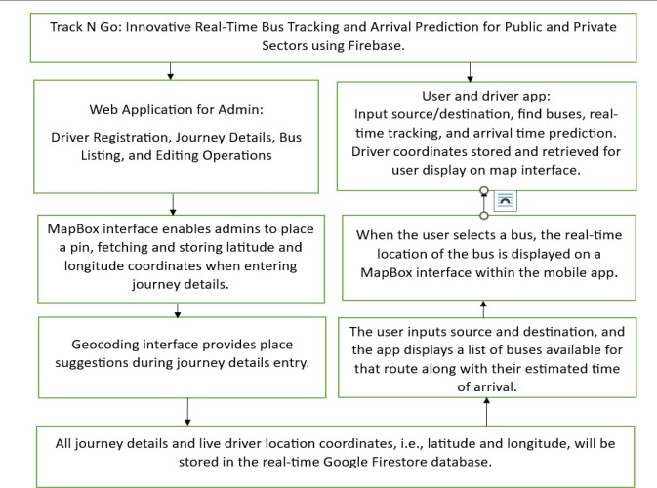

Fig 4.1.1 System Architecture

## FLOW CHART DIAGRAM

A flowchart is a diagram that depicts a process, system, or computer algorithm. They are widely used in multiple fields to document, study, plan, improve, and communicate often complex processes in clear, simple, and understandable diagrams.

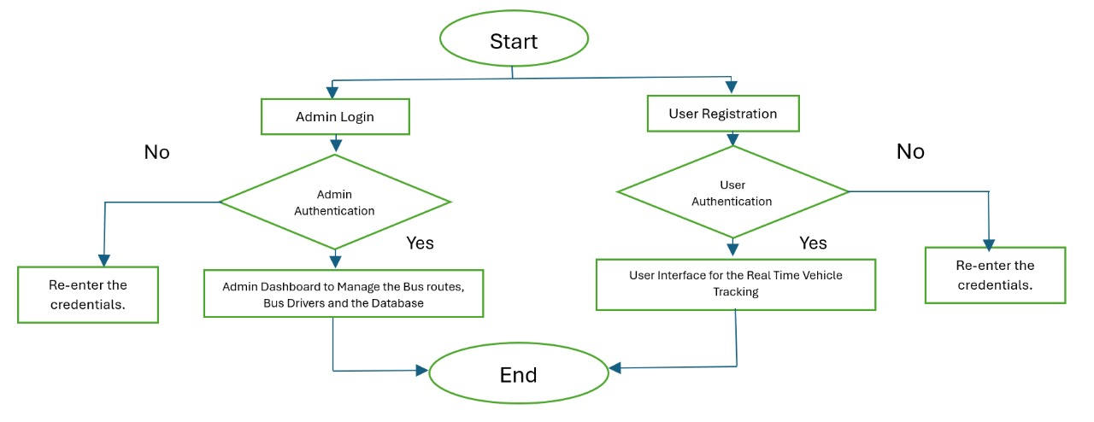

Fig 4.2.1 Flowchart

## UML DIAGRAMS

UML stands for Unified Modelling Language. In the field of object-oriented software engineering, UML is a standardized general-purpose modeling language used for designing, visualizing, building, and documenting the artifacts of software systems. The UML primarily employs graphical notations to express software system design.

The UML Diagrams include a Use Case diagram and a sequence diagram.

### USE CASE DIAGRAM

A Use Case diagram is a type of behavioral diagram defined by and created from a Use-case analysis. Its objective is to provide a graphical picture of a system's functionality in terms of actors, their objectives (expressed as use cases), and any dependencies among those use cases.

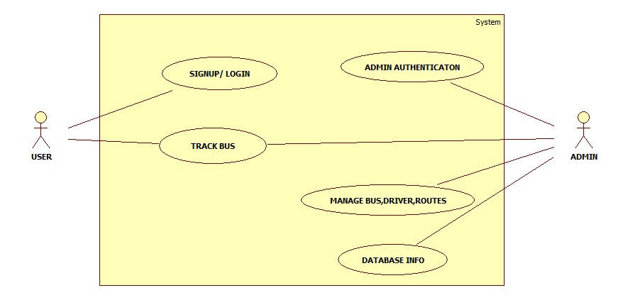

Fig 4.3.1.1 Use Case Diagram

### SEQUENCE DIAGRAM

## A sequence diagram is a type of interaction diagram that shows how objects interact in a particular scenario of a use case or a system operation. It depicts the sequence of messages exchanged between objects or components over time, typically focusing on the chronological flow of messages between objects or system components.

## 

Fig 4.3.1. 2 Sequence Diagram

**CHAPTER 5**

# IMPLEMENTATION

## TOOLS USED

### Android Studio

Android Studio is the official integrated development environment (IDE) for Android app development, provided by Google. It offers a comprehensive set of tools and features specifically designed to streamline the process of creating, testing, and debugging Android applications. Here's a detailed explanation of Android Studio:

1. **Official IDE**: Android Studio is Google's official IDE for Android app development.
2. **Comprehensive Tools**: It offers a wide range of tools for coding, designing UIs, testing, and debugging.
3. **User-Friendly Interface**: The interface is intuitive, with panels for coding, designing, and project management.
4. **Code Editor**: Features include syntax highlighting, code completion, and refactoring tools.
5. **Layout Editor**: Allows for visual design of app UIs with drag-and-drop functionality.
6. **Emulator**: Includes an Android Emulator for testing apps on virtual devices.
7. **Performance Profiler**: Helps identify and diagnose performance issues in apps.
8. **SDK Integration**: Seamlessly integrates with the Android SDK for access to tools and APIs.

### Google Firebase: Cloud-based platform for real-time database management and user authentication.

### React.js: JavaScript library for building user interfaces, used for the frontend of the web application.

### Java: Programming language used for Android app development in Android Studio.

### VS CODE

Visual Studio is a powerful Integrated Development Environment (IDE) that can be used to develop a wide range of applications for various platforms, including Windows, web, cloud, mobile, gaming, and IoT. Here are some common scenarios where Visual Studio is used:

1. **Cross-Platform**: Works on Windows, macOS, and Linux.
2. **Intuitive UI**: Clean layout with customizable themes and shortcuts.
3. **Integrated Terminal**: Run commands and scripts within the editor.
4. **Language Support**: Built-in support for various languages, extensible via extensions.
5. **Code Editing**: Syntax highlighting, code completion, folding, and navigation.
6. **Debugging**: Built-in support for debugging with breakpoints and variable inspection.
7. **Version Control**: Seamless integration with Git for version control.

## ALGORITHMS

## Public Bus Registration

Track N Go web application facilitates the seamless registration of public buses by allowing users to input city details, add stations, and submit essential journey information to Firebase Firestore. With intuitive map interactions and real-time preview features, the registration process ensures accuracy and efficiency in managing bus routes.

1. Initialize the map component and set up event listeners.
2. Handle city input changes and fetch suggestions.
3. Enable users to select a city suggestion and update the map marker.
4. Add place details and update the preview.
5. Allow users to remove added places.
6. Prompt users to enter document ID, bus number, and driver mobile number.
7. Validate input fields and display alerts for errors.
8. Submit data to Firebase.

### Code Snippet:

const handleSubmitButtonClick = async () => {

if (! documentId ||! busNumber || !driverMobileNumber) {

alert ('Please fill in all required fields.');

return;

}

if (savedPlaces.length < 2) {

alert ("Need atleast 2 Station details");

return;

}

if (driverMobileNumber. length! == 10) {

alert ('Enter a valid 10-digit number');

return;

}

const user = auth. currentUser;

if (! user) {

alert ('User not authenticated');

return;

}

const userEmail = user.email;

if (!userEmail) {

alert('User does not have an email associated with their account');

return;

}

const docRef = doc(firestore, 'publicbuses', documentId);

const docSnap = await getDoc(docRef);

if (docSnap.exists()) {

const userConfirmation = window.confirm('Data already exists. Do you want to replace it?');

if (!userConfirmation) {

return;

}

}

try {

const journeyDetails = {

busNumber,

driverMobileNumber,

Stations: savedPlaces,

userEmail,

};

const phonenumbers = {

driverMobileNumber,

};

await setDoc(doc(firestore, 'publicbuses', documentId), journeyDetails);

await setDoc(doc(firestore, 'phonenumbers',driverMobileNumber), phonenumbers);

alert('Data added to Firestore successfully');

} catch (error) {

alert('Error adding data to Firestore: ', error);

}

};

### Fetching and displaying the details.

1. **Initialization:** The component initializes state variables to manage the fetched bus details and loading state.
2. **Authentication Check:** It checks if the user is authenticated. If not, it redirects the user to the login page.
3. **Fetching Vehicles:** It asynchronously fetches bus details from Firestore when the component mounts. Once fetched, it updates the state with the retrieved data.
4. **Rendering Vehicles:** It renders the fetched bus details in the component's UI. If data is still loading, it displays a loading message. If no vehicles are found, it displays a corresponding message. Otherwise, it renders a table with the IDs of the vehicles, each linked to its details page.
5. **User Input:** The user can input city names in the search bar to search for places. The suggestions based on the input are displayed, and the user can select a suggestion to set the map location.

### Code Snippet:

const fetchVehicles = async () => {

try {

const querySnapshot = await getDocs(collection(firestore, 'publicbuses'));

const vehiclesData = querySnapshot.docs.map((doc) => ({ id: doc.id, ...doc.data() }));

setVehicles(vehiclesData);

setLoading(false);

} catch (error) {

console.error('Error fetching vehicles from Firestore:', error);

setLoading(false);

}

};

## MODULES USED

### ADMIN

1. **Authentication**: The admin module includes authentication features to ensure secure access to the system. Admins are required to log in using their credentials before accessing the dashboard.
2. **Dashboard**: Upon successful authentication, admins are presented with a dashboard that provides an overview of system activities and key metrics. The dashboard serves as a central hub for managing various aspects of the system.
3. **Bus Management**: Admins can manage buses within the system. This includes adding new buses, updating existing bus details such as routes and schedules, and removing buses when necessary.
4. **Route Management**: The admin module allows admins to define and manage bus routes. Admins can create new routes, modify existing ones, and designate stops along each route.
5. **Schedule Management**: Admins can set and update bus schedules to ensure timely arrivals and departures. This includes defining the frequency of bus trips, departure times, and any deviations or special schedules.

### USER

1. **User Registration**: The User module allows individuals to create accounts by registering with the system. Users provide necessary information such as name, email address, and password to create their profiles.
2. **Authentication**: After registration, users can log in to the system using their credentials. Authentication mechanisms ensure secure access to user-specific features and data.
3. **Profile Management**: Users can manage their profiles within the system. This includes updating personal information, changing passwords, and configuring notification preferences.
4. **Journey Planning**: The User module provides features for planning bus journeys. Users can input their current location, destination, and desired departure time to receive route options, estimated travel times, and bus schedules.
5. **Real-Time Bus Tracking**: Users can track the real-time location of buses within the system. This feature allows users to monitor bus movements, view estimated arrival times, and plan their journeys accordingly.

**CHAPTER 6**

# SYSTEM TESTING

System testing is a critical aspect of Software Quality Assurance and represents the ultimate review of specification, design, and coding. It is the process of trying to discover every conceivable fault or weakness in a work product. The purpose of testing is to discover errors. It provides a way to check the functionality of components, sub-assemblies, assemblies, and/or a finished product It is the process of exercising software with the intent of ensuring that the software system meets its requirements and user expectations and does not fail unacceptably. There are various types of tests. Each test type addresses a specific testing requirement.

Testing may be done at different levels. Each testing type level addresses a specific testing requirement.

* Unit level
* Module level
* Integration and System level

### UNIT TESTING

Unit testing involves the design of test cases that validate that the internal program logic is functioning properly and that program inputs produce valid outputs. All decision branches and internal code flow should be validated. It is the testing of individual software units of the application.it is done after the completion of an individual unit before integration. This is a structural testing, that relies on knowledge of its construction and is invasive. Unit tests perform basic tests at the component level and test a specific business process, application, and/or system configuration. Unit tests ensure that each unique path of a business process performs accurately to the documented specifications and contains clearly defined inputs and expected results.

Testing and Validation are the most important steps after the implementation of the developed system. Validation refers to the process of using the new software for the developed system in a live environment i.e., new software inside the organization, to find out the errors. The validation phase reveals the failures and the bugs in the developed system. It will come to know about the practical difficulties the system faces when operated in the true environment.

|  |  |  |  |  |  |
| --- | --- | --- | --- | --- | --- |
| **Test Case ID** | **Test Case Description** | **Input** | **Expected Output** | **Actual Output** | **Test Result** |
| TC_001 | Test with valid input | Valid name, email, mobile, and password | A successful signup message displayed | A successful signup message displayed | Passed |
| TC_002 | Test with empty fields | Empty name, email, mobile, or password | Error message "Fill all fields" displayed | Error message "Fill all fields" displayed | Passed |
| TC_003 | Test with invalid email format | Invalid email format | Error message "Invalid email address" displayed | Error message "Invalid email address" displayed | Passed |
| TC_004 | Test with invalid mobile number format | Invalid mobile number format (less than 10 digits) | Error message "Invalid mobile number" displayed | Error message "Invalid mobile number" displayed | Passed |
| TC_005 | Test with Google Signup | Click on the "Signup with Google" button | The user has to select one of its Google Accounts, after signing up successfully redirected to the Vehicle Type page. | The user has to select one of its Google Accounts, after signing up successfully redirected to the Vehicle Type page. | Passed |
| TC_006 | Entering a city name in the search bar | "Bangalore" | Suggestions list with places in Bangalore | [List of suggestions] | Passed |
| TC_007 | Adding a place without selecting coordinates | Clicking '+' button without selecting coordinates | Alert message: "Please select proper coordinate. You can drag the map pin and place where you need" | Alert message: "Please select proper coordinate. You can drag the map pin and place where you need" | Passed |
| TC_008 | Adding a place with proper details | Clicking '+' button after selecting coordinates | Place details added to the list of saved places | Place details added to the list of saved places | Passed |
| TC_009 | Removing the latest added place | Clicking the '-' button after adding a place | The latest added place was removed from the list | The latest added place was removed from the list | Passed |
| TC_010 | Entering a document ID | "Bus001" | Document ID set to "Bus001" | Document ID set to "Bus001" | Passed |
| TC_011 | Entering a bus number | "12345" | The bus number is set to "12345" | The bus number is set to "12345" | Passed |
| TC_012 | Entering a driver's mobile number | "9876543210" | Driver mobile number set to "9876543210" | Driver mobile number set to "9876543210" | Passed |
| TC_013 | Submitting the form with all required fields filled | Clicking the "Submit" button with all required fields filled | Data added to Fire store successfully | Data added to Fire store successfully | Passed |
| TC_014 | Submitting the form with incomplete details | Clicking the "Submit" button with some required fields missing | Alert message: "Please fill in all required fields." | Alert message: "Please fill in all required fields." | Passed |
| TC_015 | Submitting the form with less than 2 station details | Clicking the "Submit" button with less than 2 station details | Alert message: "Need at least 2 Station details" | Alert message: "Need at least 2 Station details" | Passed |
| TC_016 | Submitting the form with an invalid driver's mobile number | Clicking the "Submit" button with an invalid driver mobile number | Alert message: "Enter a valid 10-digit number" | Alert message: "Enter a valid 10-digit number" | Passed |
| TC_017 | Submitting the form without user authentication | Clicking the "Submit" button without user authentication | Alert message: "User not authenticated" | Alert message: "User not authenticated" | Passed |
| TC_018 | Submitting the form without an email associated with the user account | Clicking the "Submit" button without an email associated with the user account | Alert message: "User does not have an email associated with their account" | Alert message: "User does not have an email associated with their account" | Passed |
| TC_019 | Submitting the form with an existing document ID | Clicking the "Submit" button with an existing document ID | Confirmation dialog: "Data already exists. Do you want to replace it?" | Confirmation dialog: "Data already exists. Do you want to replace it?" | Passed |
| TC_020 | Removing a place by specifying an invalid index | Entering an invalid index to remove a place | Alert message: "Invalid index" | Alert message: "Invalid index" | Passed |

Table 6.1 Unit Testing

### MODULE TESTING

Module testing examines the output of every module involved. Modules are designed during the time of design. It is usually performed by the development team during the early stages of software development. However, it can also be done by independent testers as part of regression testing. There are various methods of module testing, but the most common one is black-box testing. In black-box testing, the test cases are designed based on the functionality of the code, without taking into consideration its internal structure. Other methods include white-box testing (which looks at the internal structure), grey-box testing (which combines both black-box and white-box testing), and glass-box testing (which tests all possible inputs and outputs). Module testing is done at each module using test cases as prepared above.

### INTEGRATION TESTING

Integration tests are designed to test integrated software components to determine if they actually run as one program. Testing is event driven and is more concerned with the basic outcome of screens or fields. Integration tests demonstrate that although the components were individually satisfaction, as shown by successfully unit testing, the combination of components is correct and consistent. Integration testing is specifically aimed at exposing the problems that arise from the combination of components. It is the incremental integration testing of two or more integrated software components on a single platform to produce failures caused by interface defects. The task of the integration test is to check that components or software applications, e.g. components in a software system or – one step up – software applications at the company level – interact without error.

### SYSTEM TESTING

System testing ensures that the entire integrated software system meets requirements. It tests a configuration to ensure known and predictable results. An example of system testing is the configuration-oriented system integration test. System testing is based on process descriptions and flows, emphasizing pre-driven process links and integration points. It helps in testing the finished product.

**CHAPTER 7**

# RESULTS AND DISCUSSION

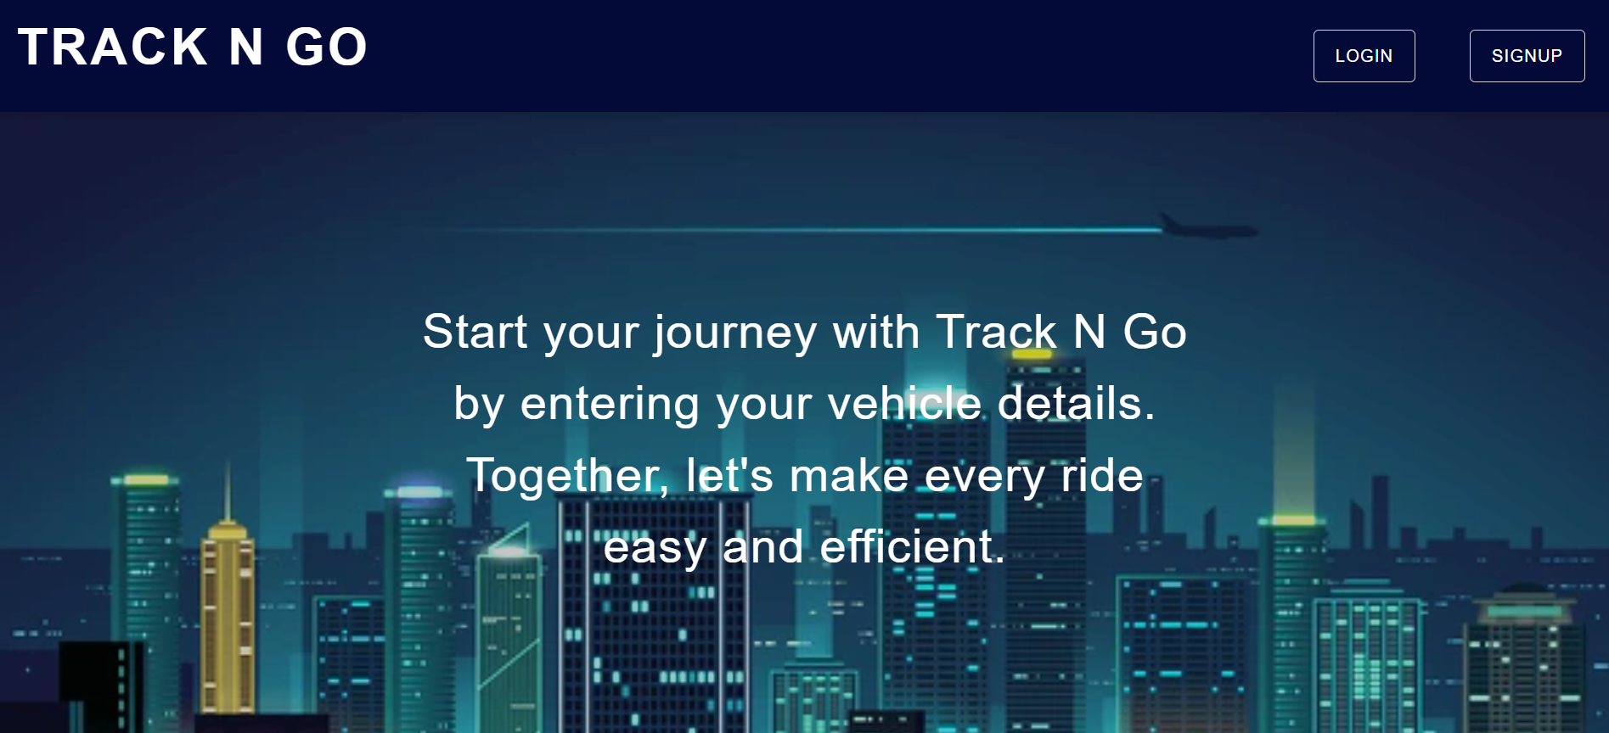

Fig 7.1 Homepage and Admin Login page to allow Admin to authenticate.

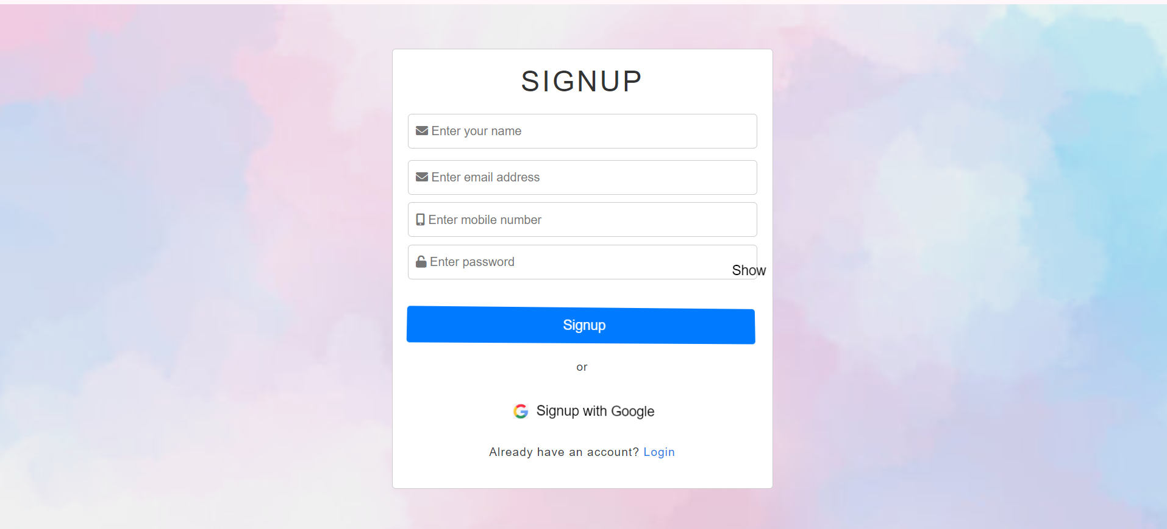

Fig 7.2 Admin Signup Page (Main admin, Organization head and Officer Login)

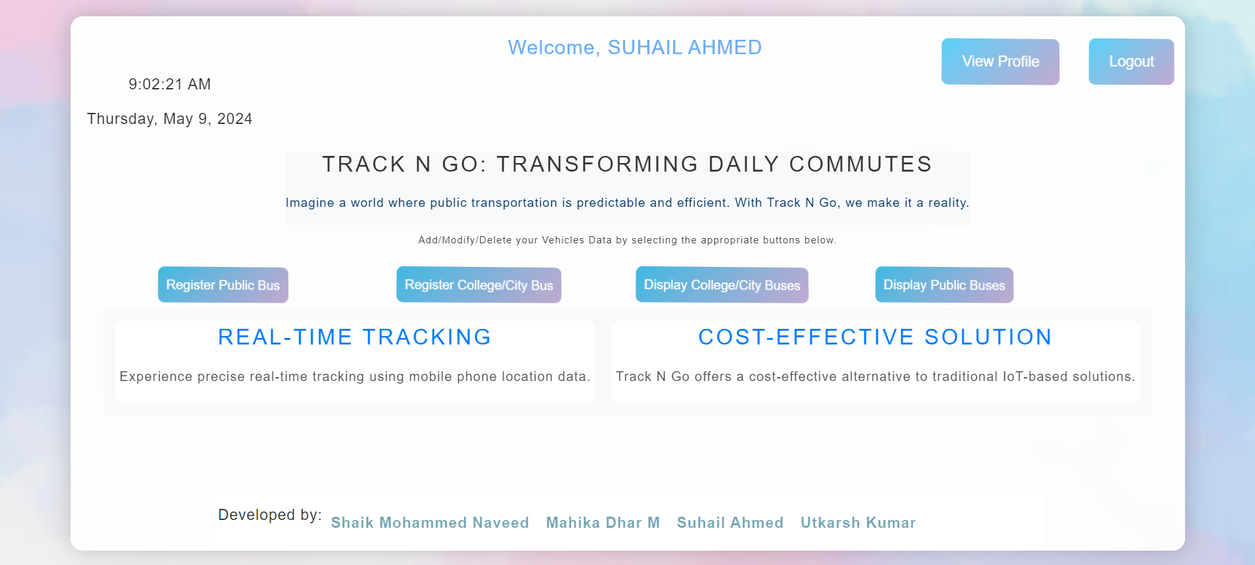

Fig 7.3 Admin dashboard page. Display various functionalities of the Track N Go Website.

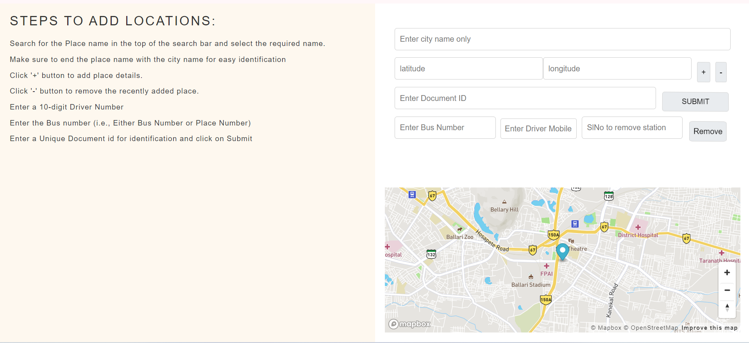

Fig 7.4 Registering of the Public buses.

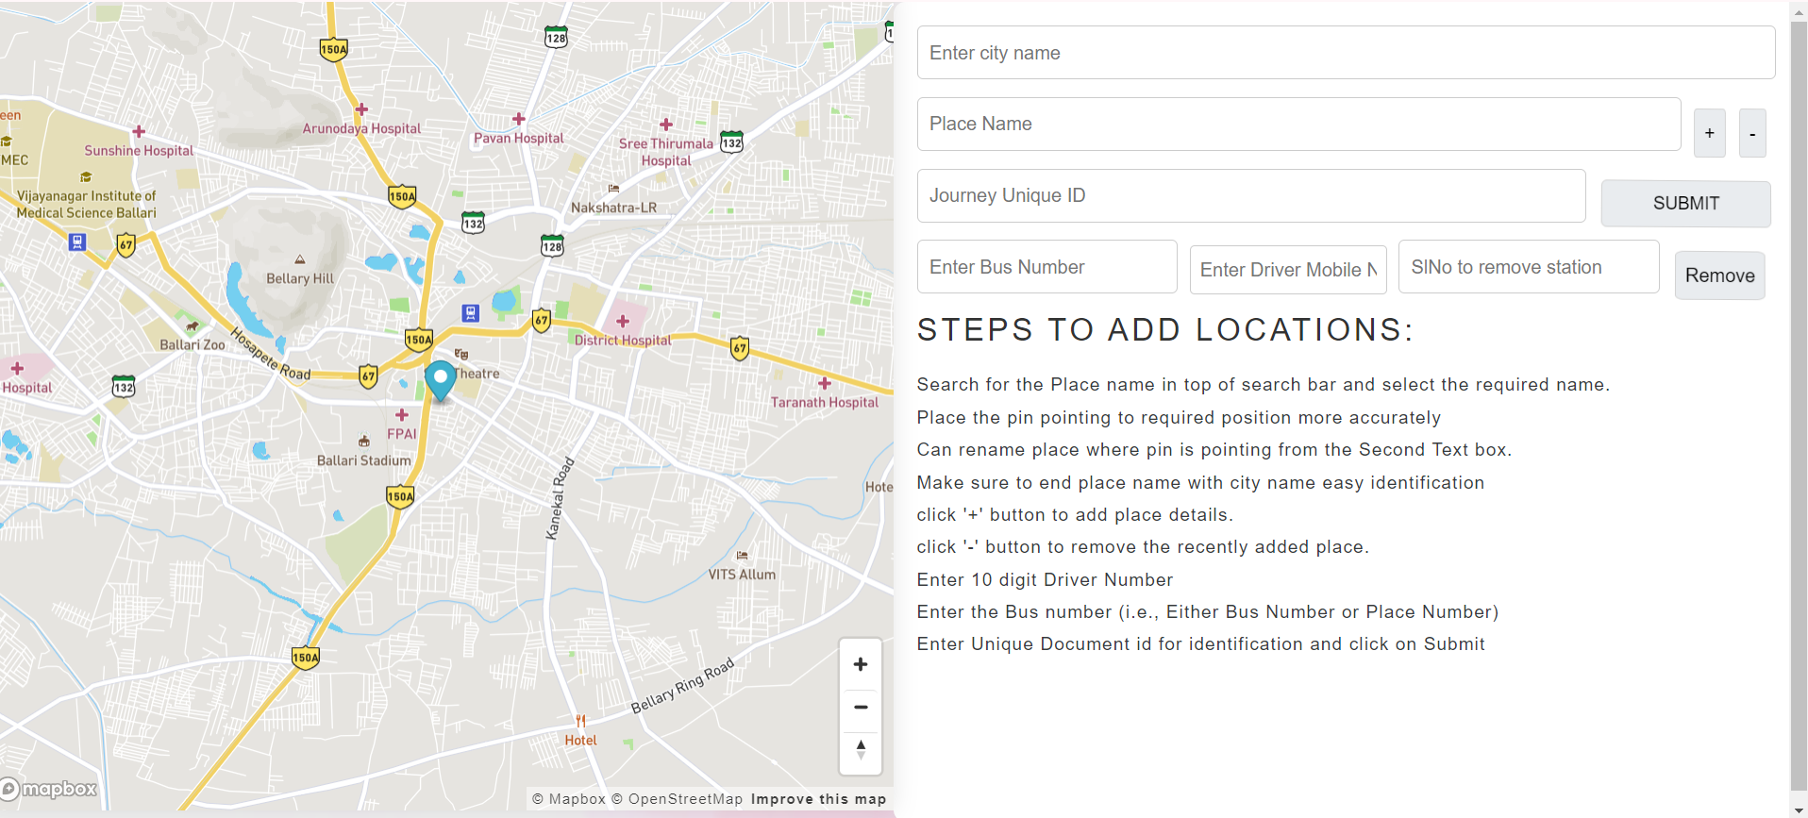

Fig 7.5 Registering of Private Buses.

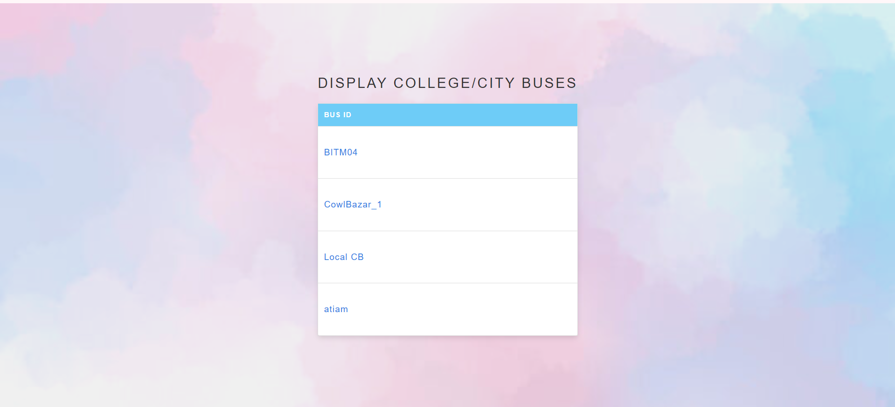

Fig 7.6 Displaying List of Private Vehicles.

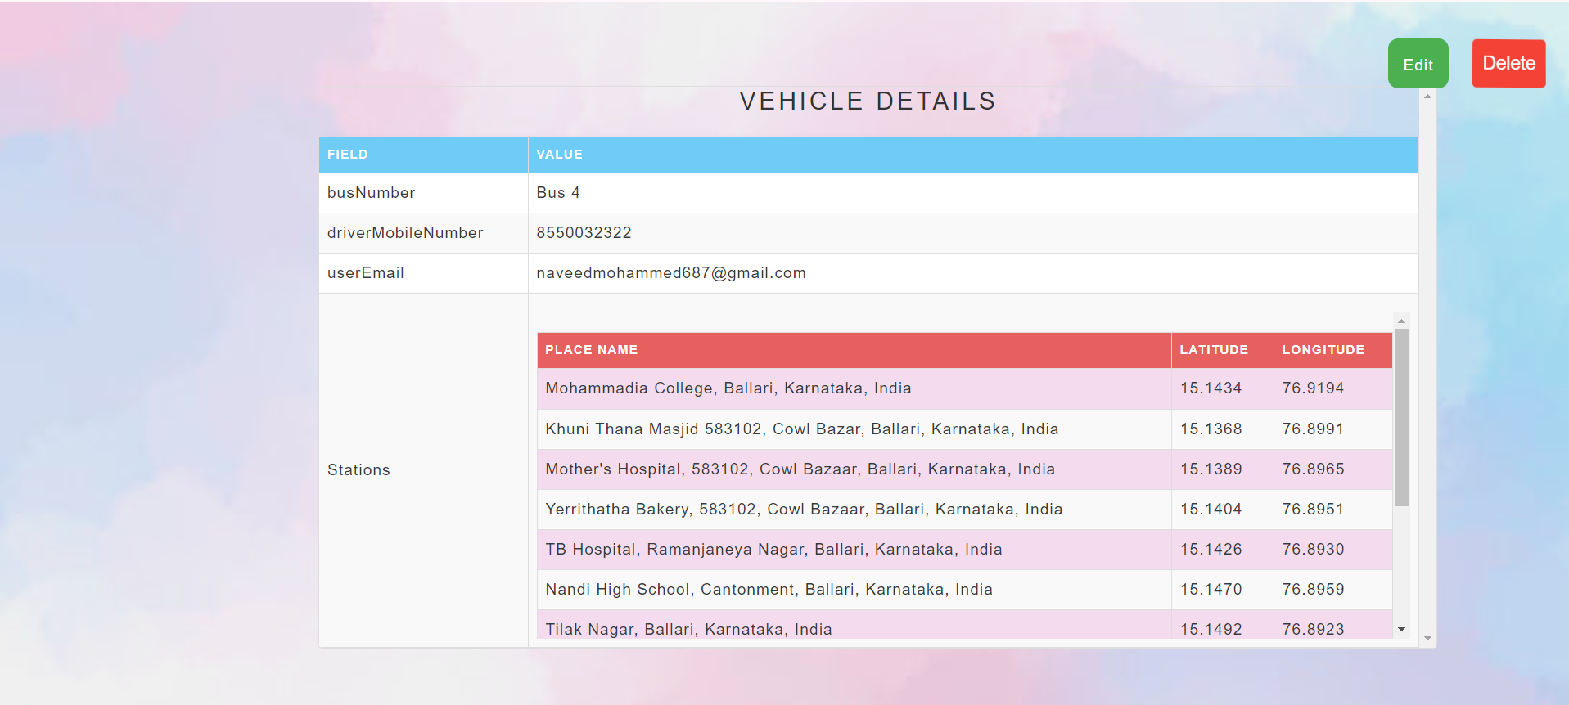

Fig 7.7 Displaying Detailed Route of the bus.

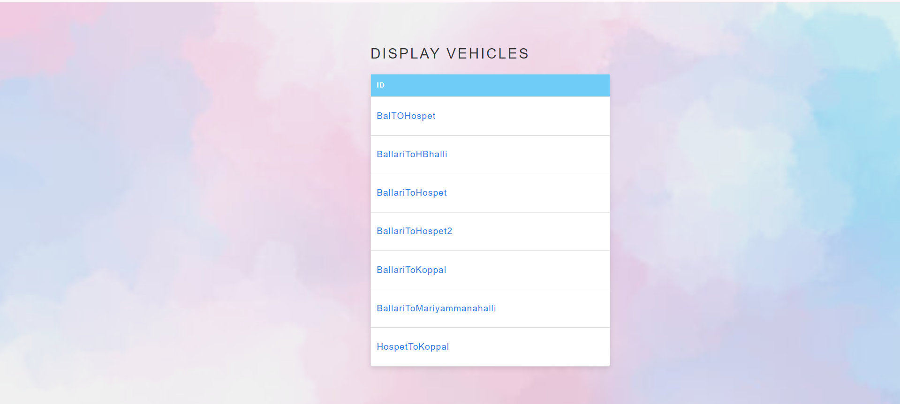

Fig 7.8 Displaying List of Government Buses.

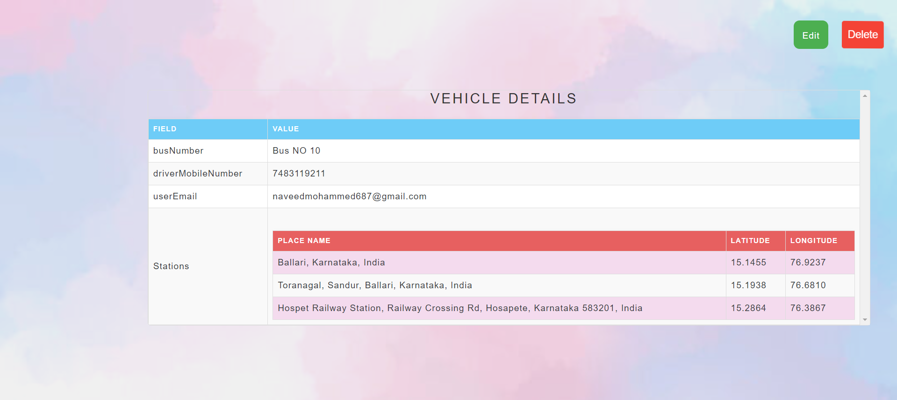

Fig 7.9 Displaying Detailed Route of Public Buses.

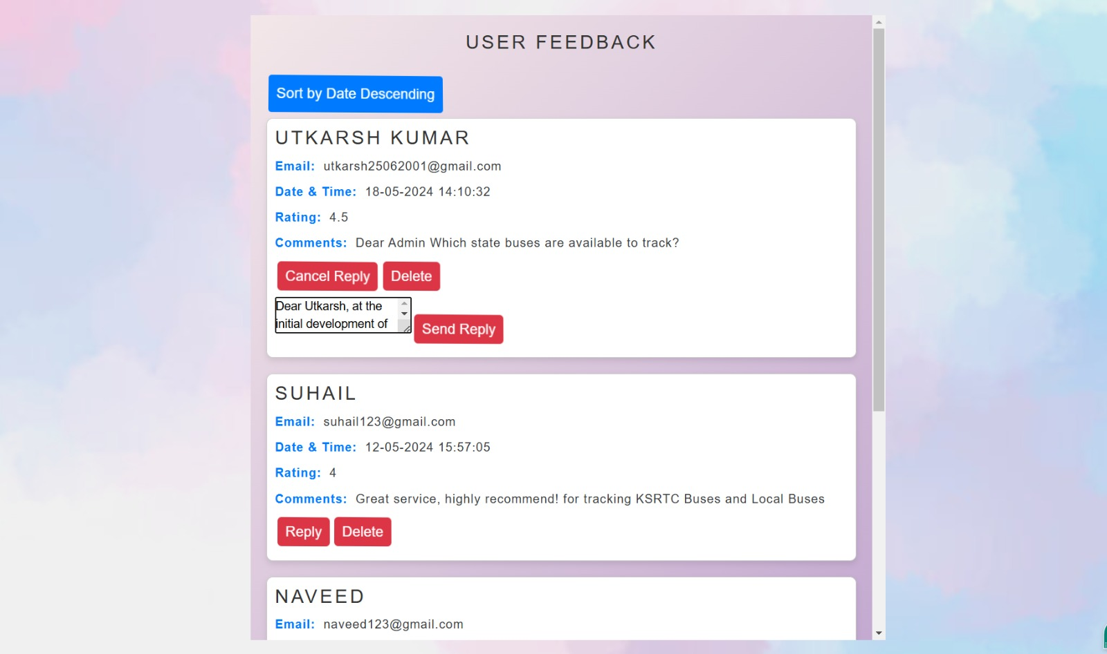

Fig 7.10 Viewing and replying to the feedback and queries from the users.

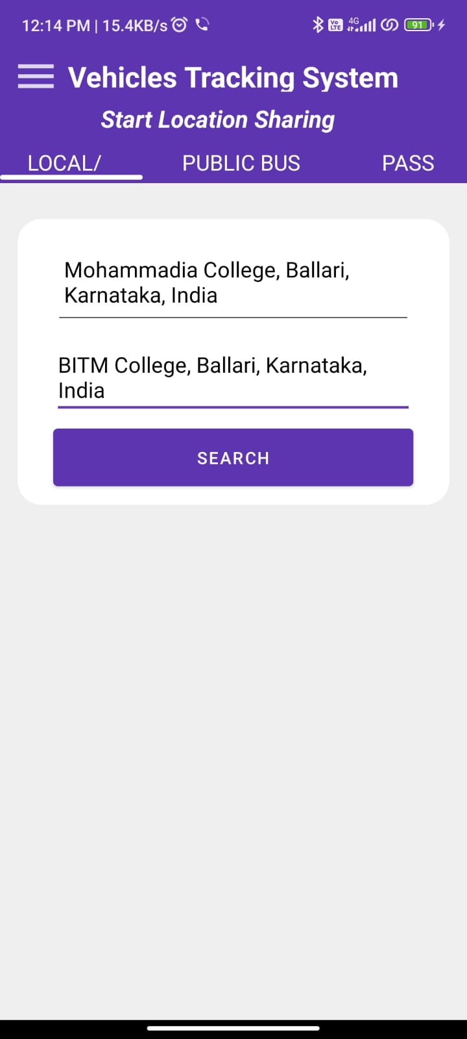

Fig 7.11 User application for bus tracking

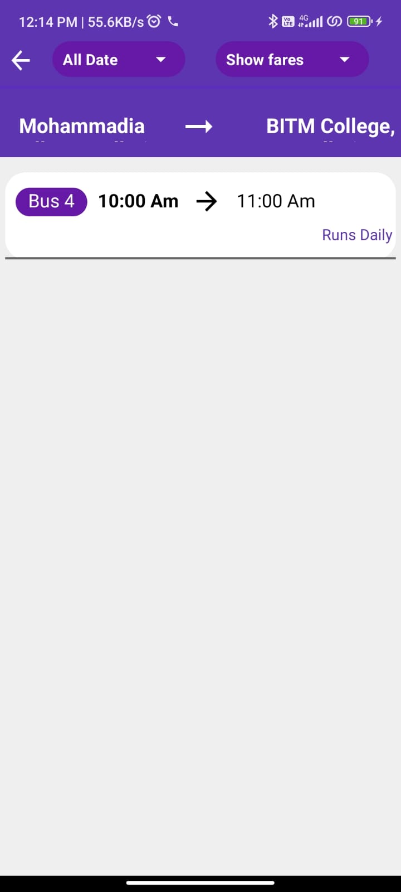

Fig 7.12 Finding the list of buses to the desired route

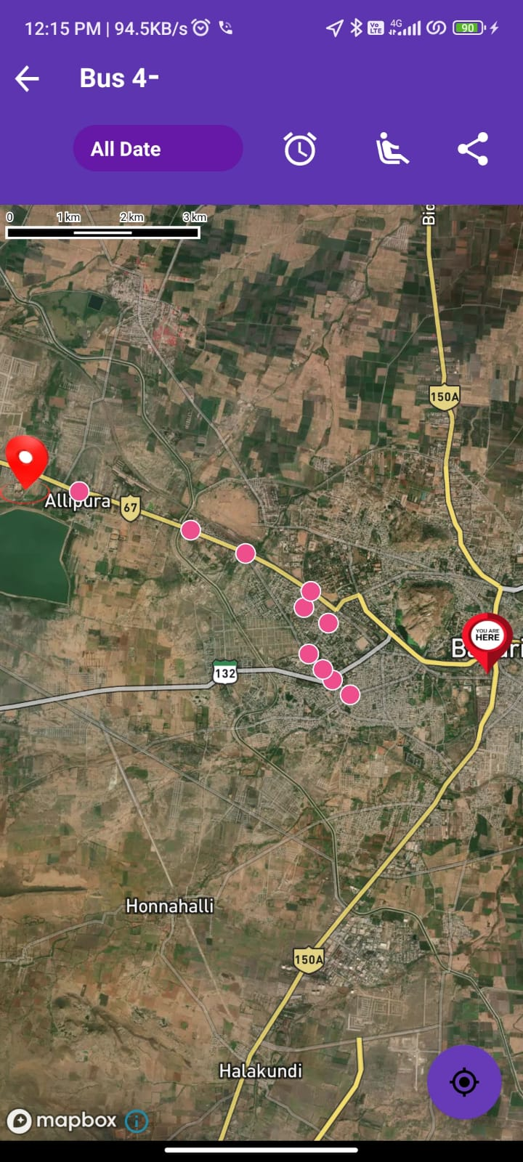

Fig 7.13 Locating of the bus on the mapbox interface.

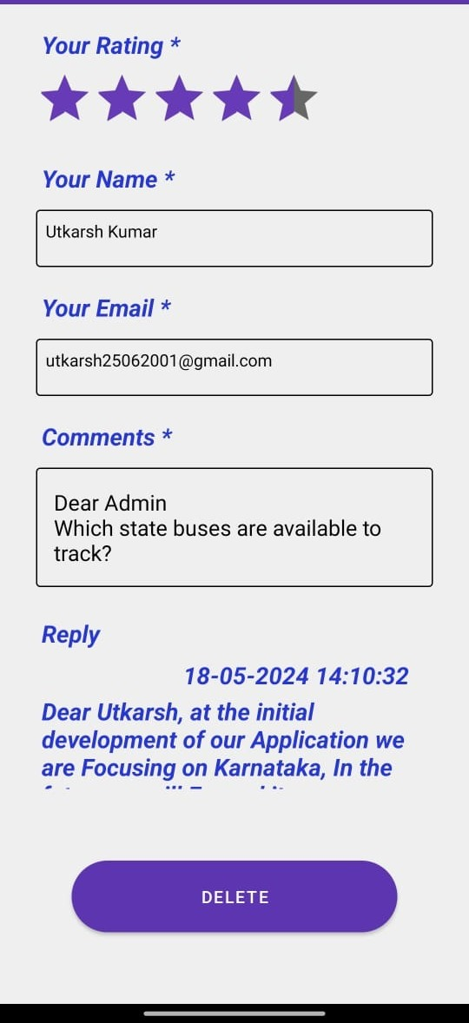

Fig. 7.14. Querying and getting back the response from the Administrator.

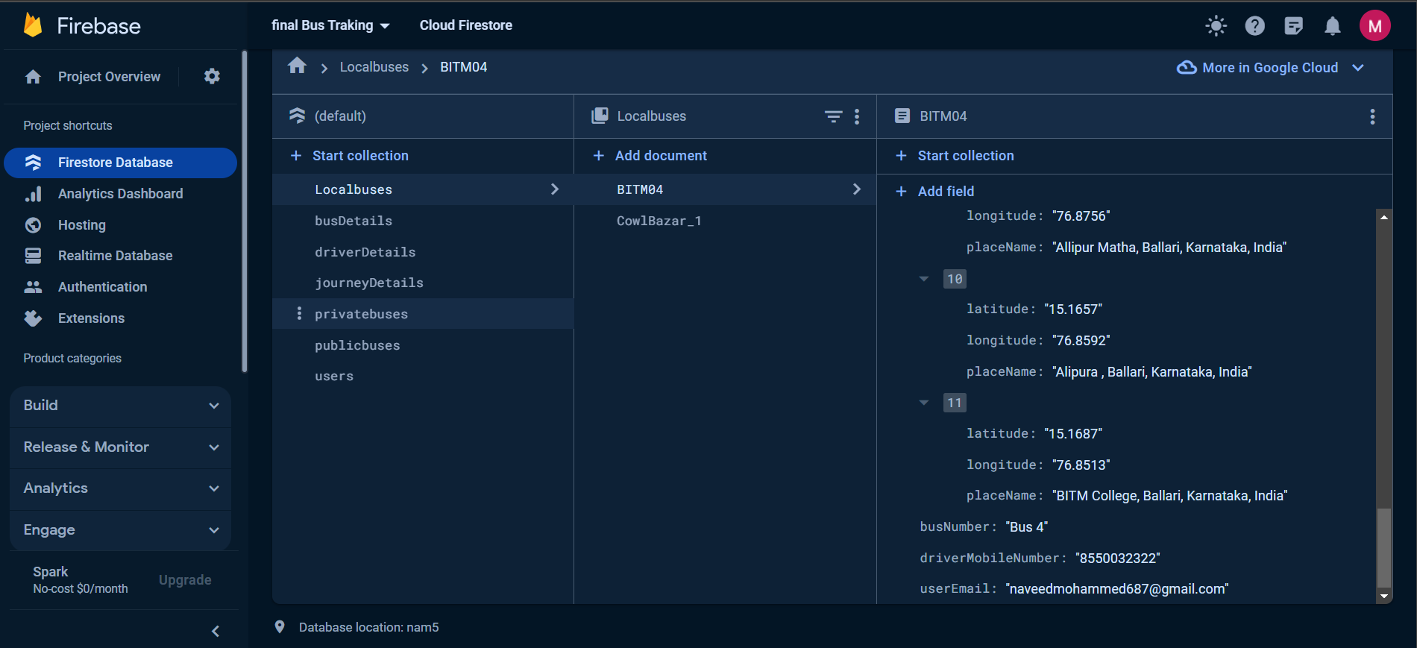

.

Fig 7.15 Fire store Database for storing of the coordinates.

**CHAPTER 8**

# CONCLUSION AND FUTURE SCROPE

### CONCLUSION

In conclusion, the "Track N Go" system offers a groundbreaking and cost-effective solution for real-time bus tracking and arrival prediction. Leveraging mobile phone location data, a serverless architecture, and cloud-based NoSQL databases, the system ensures accurate tracking and streamlined data management. Its user-friendly web interface enhances accessibility for administrators and commuters. Looking ahead, potential enhancements such as geofencing, environmental monitoring, and route optimization demonstrate the system's commitment to ongoing improvement. While successfully implemented at the Ballari Institute of Technology and Management, the project sets a benchmark for smarter transit systems. Despite its successes, limitations include potential challenges with network connectivity and scalability. The future scope involves further integration with smart city initiatives, enhanced user customization options, and collaboration with local authorities to optimize transit infrastructure and services.

### FUTURE SCOPE

### The future scope for "Track N Go" encompasses several key areas of development. Firstly, integration with smart city initiatives presents opportunities for collaboration with local government authorities to enhance urban mobility and transportation management. Secondly, enhancing user customization features allows for tailored tracking experiences, such as route preferences and notification settings. Thirdly, expanding the system's capabilities to include environmental monitoring fosters a healthier and more sustainable urban environment by integrating air quality sensors and pollution monitoring devices onto buses. Fourthly, implementing route optimization algorithms based on historical data improves bus schedules and reduces travel times. Furthermore, enhancing offline functionality ensures continuous access to essential features in areas with limited connectivity. Scalability and performance optimization remain critical to accommodate growing user bases, while strengthening data privacy and security measures safeguard sensitive information. Lastly, establishing channels for user feedback drives iterative development, guiding future enhancements and updates to ensure "Track N Go" remains a leading solution in real-time bus tracking and urban transportation management.

**CHAPTER 9**

**REFERENCES**

1. Y. Ozen, O. Ozdemir and N. Bandirmali, "Android based energy aware real-time location tracking system," 2015 Seventh International Conference on Ubiquitous and Future Networks, Sapporo, Japan, 2015,

pp. 842-844, doi: 10.1109/ICUFN.2015.7182662.

1. P. Jyothi and G. Harish, "Design and implementation of real time vehicle monitoring, tracking and controlling system," 2016 International Conference on Communication and Electronics Systems (ICCES), Coimbatore, India, 2016, pp. 1-4, doi: 10.1109/CESYS.2016.7889814.
2. S. Anand, A. Johnson, P. Mathikshara and R. Karthik, "Real-time GPS tracking using serverless architecture and ARM processor," 2019 11th International Conference on Communication Systems & Networks(COMSNETS),Bengaluru,India, 2019, pp. 541-543, doi: 10.1109/COMSNETS.2019.8711273.
3. O. D. Jimoh, L. A. Ajao, O. O. Adeleke and S. S. Kolo, "A Vehicle Tracking System Using Greedy Forwarding Algorithms for Public Transportation in Urban Arterial," in IEEE Access, vol. 8, pp. 191706- 191725,2020,doi:10.1109/ACCESS.2020.3031488.
4. M. S. A. khan, T. Akter, M. M. Y. Hossain, M. S. Hossain, S. Mazumder and M. K. Alam, "Design and Business Modeling of an IoT Based Cost-Effective Vehicular Monitoring System for Next Generation Smart Vehicle," 2020 IEEE International Women in Engineering (WIE) Conference on Electrical and Computer Engineering (WIECON-ECE), Bhubaneswar, India, 2020, pp. 440-443, doi: 10.1109/WIECON-ECE52138.2020.9398003.
5. F. Farzana, M. M. Hossain, M. M. Imtiaze, M. T. Hossain, A. S. M. M. Jameel and S. Islam, "A Real- Time Motion Based Fuel Monitoring Technique For Vehicle Tracking Systems," 2020 Emerging Technology in Computing, Communication and Electronics (ETCCE), Bangladesh, 2020, pp. 1-6, doi: 10.1109/ETCCE51779.2020.9350860.
6. M. A. Hafiizh Nur, S. Hadiyoso, F. B. Belladina, D. N. Ramadan and I. Wijayanto, "Tracking, Arrival Time Estimator, and Passenger Information System on Bus Rapid Transit (BRT)," 2020 8th International Conference on Information and Communication Technology (ICoICT), Yogyakarta, Indonesia, 2020, pp. 1-4, doi: 10.1109/ICoICT49345.2020.9166375.
7. K. Ammar, M. Jalmoud, A. Boushehri and K. Fakhro, "A Real-time School Bus Tracking and Monitoring System," 2019 IEEE 10th Annual Information Technology, Electronics and Mobile Communication Conference (IEMCON), Vancouver, BC, Canada, 2019, pp. 0654-0660, doi: 10.1109/IEMCON.2019.8936199.
8. S. A. Saad, A. '. B. Hisham, M. H. I. Ishak, M. H. M. Fauzi, M. A. Baharudin and N. H. Idris, "Real- time on-campus public transportation monitoring system," 2018 IEEE 14th International Colloquium on Signal Processing & Its Applications (CSPA), Penang, Malaysia, 2018, pp. 215-220, doi: 10.1109/CSPA.2018.8368715.

[10] M. S. Alamgir, I. Jahan, N. Aktar and A. N. Ramisa, "Chittagong University Teachers' Bus Tracking System Using Smartphone Application," 2018 4th International Conference on Electrical Engineering and Information & Communication Technology (iCEEiCT), Dhaka, Bangladesh, 2018, pp. 199 203, doi: 10.1109/CEEICT.2018.8628098.

[11] T. Noguchi, Y. C. Ting, M. Yoshida and A. G. Ramonet, "Real time Cooperative Vehicle Tracking in VANETs," 2020 29th International Conference on Computer Communications and Networks (ICCCN), Honolulu, HI, USA, 2020, pp. 1 6, doi: 10.1109/ICCCN49398.2020.9209650.

[12] J. Zhang, T. Chen and Z. Shi, "A Real Time Visual Tracking for Unmanned Aerial Vehicles with Dynamic Window," 2020 China Semiconductor Technology International Conference (CSTIC), Shanghai, China, 2020, pp. 1 3, doi: 10.1109/CSTIC49141.2020.9282552.

**Revolutionizing Bus Tracking and Arrival Prediction in Real Time for Both Public and Private Sectors, Powered by Firebase**

Mohammed Shafiulla  
*Department of Computer Science and Engineering*  
*Ballari Institute of Technology & Management*Ballari, India  
[mdshafi@bitm.edu.in](mailto:mdshafi@bitm.edu.in)

Suhail Ahmed  
*Department of Computer Science and Engineering*  
*Ballari Institute of Technology & Management*Ballari, India  
[suhailcmmb@gmail.com](mailto:suhailcmmb@gmail.com) Abdul Lateef Haroon P S  
*Department of Electronics and Communication Engineering*   
*Ballari Institute of Technology and Management*Ballari, India  
[abdul.lh@bitm.edu.in](mailto:abdul.lh@bitm.edu.in)

Mahika Dhar M   
*Department of Computer Science and Engineering*  
*Ballari Institute of Technology & Management*Ballari, India  
[mahikadhar1@gmail.com](mailto:mahikadhar1@gmail.com) Shaik Mohammed Naveed  
*Department of Computer Science and Engineering*  
*Ballari Institute of Technology and Management*Ballari, India  
[naveedmohammed687@gmail.com](mailto:naveedmohammed687@gmail.com)

Utkarsh Kumar  
*Department of Computer Science and Engineering*  
*Ballari Institute of Technology & Management*Ballari, India  
[utkarsh25062001@gmail.com](mailto:utkarsh25062001@gmail.com)

***Abstract*— Public transport systems often face challenges related to reliability and efficiency, leading to inconvenience and uncertainty for passengers. Existing solutions for real-time bus monitoring typically rely on expensive Internet of Things (IoT) components. This paper presents Track N Go, a cost-effective alternative for real-time monitoring of public buses and taxis using mobile phone location data. The system utilizes a robust backend system built with Java and React.Js for the user interface. Integration of GPS via the Map Box API and Firebase database ensures accurate location tracking. Track N Go provides accurate real-time monitoring, addressing challenges associated with public transport and improving overall urban mobility. The system enhances convenience and peace of mind for passengers by delivering reliable and user-centric solutions. The evaluation of Track N Go demonstrates its effectiveness in improving urban mobility and transit services. By offering a reliable and cost-effective solution for real-time bus monitoring, Track N Go aims to streamline daily commutes and make public transport more efficient and predictable.**

**Keywords---Real-time tracking, Bus monitoring, Firebase, Urban transportation, Cost-effective solution, GPS integration**

**Top of Form**

**Introduction**

In the bustling landscape of urban living, optimizing public transportation systems emerges as a pivotal endeavor in ensuring seamless and delightful commuting experiences. However, this pursuit is laden with intricate challenges. Traditional methods of bus tracking and management often entail complex and prohibitively expensive implementations, typically reliant on Internet of Things (IoT) technologies. While undeniably effective, these approaches erect barriers to scalability and accessibility, leaving commuters frustrated and transit agencies burdened. The inception of "Track N Go" springs forth from a profound recognition of these challenges and an impassioned call for a paradigm shift in urban transportation solutions. Unlike its predecessors, Track N Go capitalizes on the ubiquitous nature of mobile phones and their inherent location tracking capabilities to offer a revolutionary approach to real-time bus tracking. This innovation not only significantly mitigates operational costs but also democratizes bus tracking technology, rendering it accessible and scalable across both public and private sectors. The driving force behind Track N Go lies in a fervent desire to elevate the overall journey experience for urban commuters. Beyond the mere task of ensuring buses adhere to schedules, the project aspires to craft a more inclusive, cost-effective, and passenger-centric approach to urban commuting. By strategically harnessing the power of mobile technology, Track N Go endeavors to meet the immediate need for efficient bus tracking while sowing the seeds for future advancements in urban mobility solutions. The objectives of Track N Go are multifaceted and deeply human-centered. Primarily, the project seeks to confront the challenges posed by traditional bus tracking methods by offering a cost-effective, scalable, and intuitively designed alternative. Moreover, Track N Go endeavors to enrich the reliability and efficiency of public transportation systems, fostering a sense of ease and comfort among passengers throughout their journeys. The paramount contribution of this research lies in its innovative use of mobile technology to revolutionize bus tracking and management. By introducing a disruptive solution that sidesteps the complexities associated with traditional IoT implementations, Track N Go heralds a new era of accessible and inclusive urban transportation. This paper unfolds as a meticulously structured journey: Section II delves into a comprehensive review of existing literature and the formidable challenges confronting traditional bus tracking methods. Section III meticulously outlines the methodology and approach embraced in the development of Track N Go. Section IV unfolds the results and discussions, shedding light on the system's remarkable features and functionalities. Section V offers a comparative analysis with existing systems, followed by a nuanced discussion of the qualitative and quantitative performance analyses. Finally, Section VI gracefully concludes the paper with a thoughtful summary of the findings and thoughtful recommendations for future research endeavors.

1. ***Objectives***

* To provide an accurate and real-time bus tracking system.
* To create user-friendly interfaces for admins and commuters, improving productivity and convenience.
* To offer a cost-effective real-time tracking solution.
* To minimize the reliance on IoT components and reduce costs while maintaining security.

**LITERATURE SURVEY**

1. R. Liu et al. [1] present a real-time object-tracking system utilizing a traditional ant colony algorithm, enhancing it for improved tracking performance. By establishing an embedded platform based on this enhanced algorithm, it aims to achieve better real-time tracking capabilities. Through algorithm analysis and experimental comparisons, the study evaluates the performance of the ant colony algorithm and its improvements. Results indicate that with particle filtering technology, the enhanced algorithm achieves a notable response time reduction, maintaining reaction times within 4 seconds.
2. M. S. Rudramurthy et al. [2] propose a vehicle tracking system that integrates smartphone technology with GPS and mobile communication to enable real-time monitoring of vehicle movement. Utilizing the Google Maps API, users can track the vehicle's location on their smartphone app and receive notifications upon entering or leaving predefined geofenced areas. Additionally, users can access features such as browsing news, profile management, and lodging grievances within the application. Overall, the system offers continuous vehicle tracking, distance estimation to destinations, and geofencing notifications for enhanced user convenience and control.
3. S. S. P. Naresh et al. [3] implement a real-time vehicle detection system using the YOLO algorithm. It processes images and videos to identify vehicles and classify them into cars, trucks, and buses using DNN models. Additionally, the system tracks vehicle movement across frames to count total vehicles passing through an area. Results are presented in a user-friendly graphical interface, with applications in traffic management, surveillance, and security systems.
4. R. Vyas et al. [4] address challenges in tracking college buses. A mobile app using Flutter, IoT, and GPS aims to offer real-time tracking, route info, and arrival times, easing transportation for students and faculty.
5. Z. Wang et al. [5] tackle ship navigation challenges. Their real-time tracking method improves accuracy, validated through simulations and sea tests, promising enhanced ship navigation and trajectory analysis.
6. H. Stuckey et al. [6] present a 3-D UAV tracking system. Utilizing a single camera and LED marker, it achieves precise location estimation comparable to motion-capture systems, offering potential for mobile UAV tracking applications.
7. Y. Zhou et al. [7] explore the real-time prediction of track curvature in rail vehicles using gyroscopes and GPS sensors. Two methods, the Gyro method, and the GPS method, are proposed. The Gyro method calculates curvature based on car body yaw rate and velocity, while the GPS method uses vehicle trajectory. Results show that the Gyro method, with lower noise, achieves greater precision compared to the GPS method.
8. H. Fu et al. [8] propose a model predictive control (MPC) trajectory tracking method for Unmanned Surface Vehicles (USVs) to address issues of long calculation time and poor real-time performance. The method involves adjusting the control horizon step size using move blocking and integrating it into the quadratic programming solution process to reduce calculation time. Experiments comparing MPC with and without move blocking show a 15.79% reduction in average calculation time with move blocking, demonstrating improved efficiency.
9. Y. Ozen et al. [9] present a specialized system for Alzheimer's patients, using energy-efficient GPS monitoring during immobility. It incorporates a hybrid mobile positioning technique and extends beyond location tracking to address medical aspects.
10. P. Jyothi and G. Harish [10] introduce a two-module system, utilizing GPS for real-time location and GSM for alert messages in vehicle tracking. It detects path deviations and speed, incorporating a gas leakage sensor (MQ 6) and temperature sensors. The future scope involves implementing measures to reduce accidents.
11. S. Anand et al. [11] integrate a GPS module sending coordinates to a microcontroller. It communicates through a Wi-Fi module for cloud transmission, employing a serverless architecture to store coordinates.
12. O. D. Jimoh et al. [12] present a vehicle tracking system using greedy forwarding algorithms for public transportation in urban areas. Their system addresses the need for efficient tracking in urban environments by employing greedy forwarding algorithms, which optimize route selection for vehicles, ensuring timely and accurate tracking information.
13. M. S. A. Khan et al. [13] design and model an IoT-based cost-effective vehicular monitoring system for next-generation smart vehicles. Their system integrates IoT technologies to monitor vehicle parameters in real-time, providing valuable data for vehicle maintenance and performance optimization. The cost-effective design makes it accessible for widespread adoption in smart vehicle applications.
14. F. Farzana et al. [14] propose a real-time motion-based fuel monitoring technique for vehicle tracking systems. Their technique utilizes motion sensors to monitor vehicle movement patterns and estimate fuel consumption in real-time. This enables efficient fuel management and helps prevent fuel theft or unauthorized usage, enhancing overall vehicle tracking system functionality.
15. M. A. Hafiizh Nur et al. [15] present a tracking, arrival time estimator, and passenger information system on Bus Rapid Transit (BRT). Their system integrates GPS tracking, arrival time estimation algorithms, and passenger information displays to improve the efficiency and user experience of BRT systems. Passengers can access real-time information for better trip planning and management.
16. K. Ammar et al. [16] develop a real-time school bus tracking and monitoring system. Their system offers parents and school administrators the ability to track school buses in real-time using GPS technology. It enhances student safety by providing accurate arrival times and alerts for parents, ensuring timely pick-ups and drop-offs.
17. S. A. Saad et al. [17] introduce a real-time on-campus public transportation monitoring system. Their system utilizes GPS devices installed on buses, a web application, and ETA calculations to provide real-time updates on bus locations and arrival times. It enhances campus transportation efficiency and convenience for students and staff.
18. M. S. Alamgir et al. [18] design a real-time bus tracking system for Chittagong University teachers' buses using smartphone apps. Their system utilizes GPS technology and smartphone applications to provide accurate and timely bus location information for university faculty. It improves transportation accessibility and efficiency within the university campus.
19. T. Noguchi et al. [19] propose a cooperative real-time vehicle tracking method in VANETs. Their method leverages vehicle-to-vehicle and vehicle-to-roadside unit communication to enable real-time collaboration in tracking vehicle movements. This enhances overall traffic management and safety in vehicular ad hoc networks.
20. J. Zhang et al. [20] present DyWinSiam, a real-time visual tracking framework for UAVs using deep neural networks. Their framework employs advanced deep learning techniques to achieve fast and accurate visual tracking of unmanned aerial vehicles. This enables UAVs to navigate and perform tasks more efficiently in various applications such as surveillance and monitoring.

**III. METHODOLOGY**

1. System Architecture and Components

Overall Architecture: The real-time vehicle tracking system is designed with a modular and scalable architecture, featuring two primary components: a web application for administrative tasks and a mobile application for user interactions.

2. Key Components

Web Application: This component manages buses, drivers, and system configurations. It seamlessly integrates with the MapBox API and the Fire store database, with responsibilities including bus and driver management and real-time tracking configurations.

Mobile Application: The mobile app provides an intuitive user interface for tracking buses and receiving relevant information. It utilizes the MapBox API and communicates with the Fire store database, handling user authentication, registration, real-time bus tracking, and arrival time prediction.

MapBox API: Integrated into both applications, the MapBox API ensures consistent map interfaces and provides geocoding/reverse geocoding services. Key features include automated bus stop entries and accurate coordinate updates.

Fire store Database: Chosen for its real-time synchronization capabilities and scalability, the Fire store database stores comprehensive details about buses, drivers, and routes, enabling seamless synchronization and real-time updates.

3. Data Collection and Database Design

I) Data Collection Process: During bus and driver registration, essential details such as bus numbers, driver's mobile numbers, and email IDs are captured. Geocoding is used to automate bus stop entries, and reverse geocoding ensures accurate updates.

ii) Database Structure Fire Store Collections: The database is organized into collections for buses, drivers, and routes, facilitating efficient storage and retrieval of relevant data.

4. Map Integration and Geocoding

i) MapBox API Integration: The MapBox API is integrated into both web and mobile applications, providing consistent map interfaces. Geocoding enhances data management efficiency by automating bus stop entries.

ii) Reverse Geocoding: Triggered when administrators place pins on the map, reverse geocoding ensures accurate latitude and longitude updates for bus stop locations.

5. User Registration and Authentication

i) User Registration: The mobile application enables users to register using their email ID and set a secure password.

ii) Authentication: Robust authentication mechanisms are implemented to ensure data security, with authorization levels defined for different user roles.

6. User Interface Design

i) Design Principles: The system adheres to intuitive design principles, focusing on providing a seamless and user-friendly experience.

7. Admin Editing Features

i) Functionalities for Administrators: An admin control panel empowers administrators to add/delete bus stops, modify driver details, and maintain an updated database, critical for adapting to dynamic operational requirements.

**Block Diagram**

The block diagram offers a comprehensive view of the bus tracking system's architecture, focusing on its web-based application. At its core lies a central server facilitating communication and data exchange among various components. The diagram emphasizes the crucial connectivity between mobile applications for users and drivers with the central server, enabling real-time interaction. Users can plan trips, monitor buses, and receive accurate arrival time estimates, enhancing urban transit navigation. The admin web application serves as a centralized hub for managing system aspects, ensuring smooth operations. Supporting services like a robust database for storing essential information and a geocoding service for accurate location data further enhance system functionality and reliability.

Track N Go: Innovative Real-Time Bus Tracking and Arrival Prediction for Public and Private Sectors using Firebase.

Web Application for Admin:

Driver Registration, Journey Details, Bus Listing, and Editing Operations

User and driver app:

Input source/destination, find buses, real-time tracking, and arrival time prediction. Driver coordinates stored and retrieved for user display on map interface.

When the user selects a bus, the real-time location of the bus is displayed on a MapBox interface within the mobile app.

MapBox interface enables admins to place a pin, fetching and storing latitude and longitude coordinates when entering journey details.

Geocoding interface provides place suggestions during journey details entry.

The user inputs source and destination, and the app displays a list of buses available for that route along with their estimated time of arrival.

All journey details and live driver location coordinates, i.e., latitude and longitude, will be stored in the real-time Google Fire store database.

Figure 1: Block diagram depicting the architecture of the web-based bus tracking system.

**Flow Chart**

Admin side application

Add or change details of public (Government) bus details, driver, and journey time information.

Add or change college bus details, driver, and journey time information.

**Flow Chart**

Changes reflected to the user.

User application will fetch the data from the server.

Government bus

Users input source and destination; app displays buses on that route, allowing tracking and showing expected timings for users to reach the bus stop accordingly.

User will select the type of vehicle.

College bus

The user will select the bus number and will be able to track the real time location of the bus and the estimated time of arrival.

Government bus

Users input source and destination; app displays buses on that route, allowing tracking and showing expected timings for users to reach the bus stop accordingly.

Getting feedback from user

To admin

Figure 2: Flow chart illustrating the bus tracking system's data flow and user interactions.

The central server collects and manages bus data, while an admin dashboard allows authorized personnel to input and manage information. A mobile application serves both college and public bus users, enabling real-time bus tracking and access to estimated arrival times. This system ensures transparency and convenience for both administrators and users.

**Proposed Method**

"Track N Go," is introduced as a real-time bus monitoring system designed to enhance public transportation services. Unlike traditional methods that rely on costly IoT components, Track N Go utilizes mobile phone location data for cost-effective and scalable bus tracking. The system's backbone is a robust backend developed with Java, ensuring reliability and performance. The user interface is built on React.js for a user-friendly experience. Integration of GPS via the Map Box API provides precise location information, and Firebase serves as the database for real-time storage of driver location coordinates. The system aims to simplify daily commutes, making them more efficient and predictable by delivering precise user-centric solutions. It addresses challenges associated with public transportation, offering convenience and peace of mind to passengers. Through a comprehensive evaluation, the effectiveness of Track N Go in improving urban mobility and transit services is demonstrated.

**Proposed Work**

The proposed system, "Track N Go," introduces a novel real-time bus monitoring solution aimed at enhancing public transportation services. Unlike traditional methods that rely on expensive IoT components, Track N Go leverages mobile phone location data to offer a cost-effective and scalable alternative. The system's architecture includes a robust backend developed with Java, a user-friendly interface built on React.js, and integration of GPS via the Map Box API. Firebase serves as the database for real-time storage of driver location coordinates. The system's objectives include providing accurate and real-time bus tracking, creating user-friendly interfaces for administrators and commuters, offering a cost-effective tracking solution, and minimizing reliance on IoT components to reduce costs while maintaining security. The proposed system utilizes mobile phone location data instead of expensive IoT components for bus tracking, significantly reducing operational costs. By leveraging widely available technology and cost-effective solutions such as Firebase for real-time data storage, the system offers a scalable and affordable alternative for both the public and private sectors. This approach ensures that private bus operators can benefit from real-time tracking capabilities without the need for extensive hardware investments, ultimately reducing their operational expenses while enhancing service quality for commuters.

**Formula Used**

The Haversine formula is a mathematical equation used in geographical calculations, particularly in GPS systems, to determine the distance between two points on the Earth's surface given their latitude and longitude coordinates. It calculates the great-circle distance, which is the shortest distance over the Earth's surface, assuming it is a perfect sphere. The formula takes into account the curvature of the Earth and is expressed as

$d=2r arcsin(\sqrt{\sin^{2}\left(\frac{Δlat}{2}\right)+cos(lat1).cos(lat2).\sin^{2}\left(\frac{Δlong}{2}\right)})$.. (1)

In Eq. (1) d represents the distance between the two points, r is the radius of the Earth, lat1, and lat2 are the latitudes of the two points, and long is the difference in longitudes between the points. This formula is essential for vehicle tracking projects, aiding in the calculation of distances between a vehicle's current location and a desired destination.

Accuracy Percentage = (1 – (Distance between Actual and GPS Shared Location / Maximum Possible Distance between Actual and GPS Shared Location)) * 100

Where, GPS Shared Longitude = Actual Longitude + (Scaling Factor * Longitude Deviation)

GPS Shared Latitude = Actual Latitude + (Scaling Factor * Latitude Deviation)

Scaling Factor = 0.00001

Longitude Deviation = Velocity * 0.00001

Latitude Deviation = Velocity * 0.00001

**TABLE I**

|  |  |  |  |  |  |  |
| --- | --- | --- | --- | --- | --- | --- |
| **Actual Latitude** | **Actual Longitude** | **Velocity (km/h)** | **Delay (milliseconds)** | **GPS Shared Latitude** | **GPS Shared Longitude** | **Accuracy Percentage** |
| 15.7749 | 75.4194 | 10 | 500 | 15.77491 | 75.41941 | 99.9333 |
| 15.7128 | 75.0060 | 12 | 600 | 15.71292 | 75.00606 | 99.9295 |
| 15.0522 | 75.2437 | 15 | 700 | 15.05223 | 75.24367 | 99.9376 |
| 15.5074 | 75.1278 | 20 | 800 | 15.50746 | 75.12776 | 99.9316 |
| 15.8566 | 75.3522 | 25 | 900 | 15.85663 | 75.35225 | 99.9417 |
| 15.5200 | 75.4050 | 30 | 1000 | 15.52003 | 75.40503 | 99.9365 |
| 15.7749 | 75.4194 | 35 | 1100 | 15.77494 | 75.41937 | 99.9338 |
| 15.0522 | 75.2437 | 40 | 1300 | 15.05227 | 75.24367 | 99.9287 |
| 15.5074 | 75.1278 | 30 | 1000 | 15.50748 | 75.12771 | 99.9325 |
| 15.8566 | 75.3522 | 25 | 900 | 15.85663 | 75.35225 | 99.9399 |
| 15.5200 | 75.4050 | 20 | 800 | 15.52003 | 75.40503 | 99.9324 |
| 15.7749 | 75.4194 | 15 | 700 | 15.77491 | 75.41943 | 99.9328 |
| 15.7128 | 75.0060 | 18 | 800 | 15.71286 | 75.00599 | 99.9391 |

Table 1: Sample records showing actual and GPS shared positions of a moving vehicle, collected for testing real-time location accuracy at different velocities.

The above Table I represents the 20 sample records collected while testing the real-time location of the moving vehicle. This represents the actual & GPS Shared position of the vehicle. Since there will be variations in showing the real-time location of the moving vehicle depending on the Velocity it moves, came up with testing the Actual and GPS Shared Location variation in different Velocities to identify the time gap and train the module to predict and show the actual location by modifying the GPS Shared location based on these data.

**IV. Results and Discussion.**

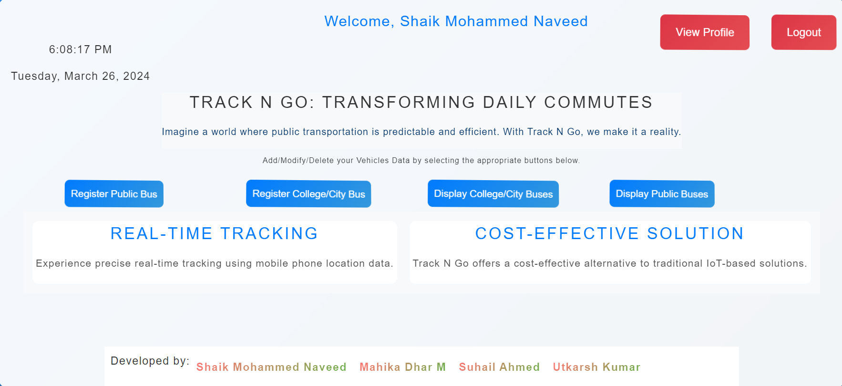

Figure 3: Admin Login

Figure 3 depicts the admin home page of the Web Application following a successful login/signup process.

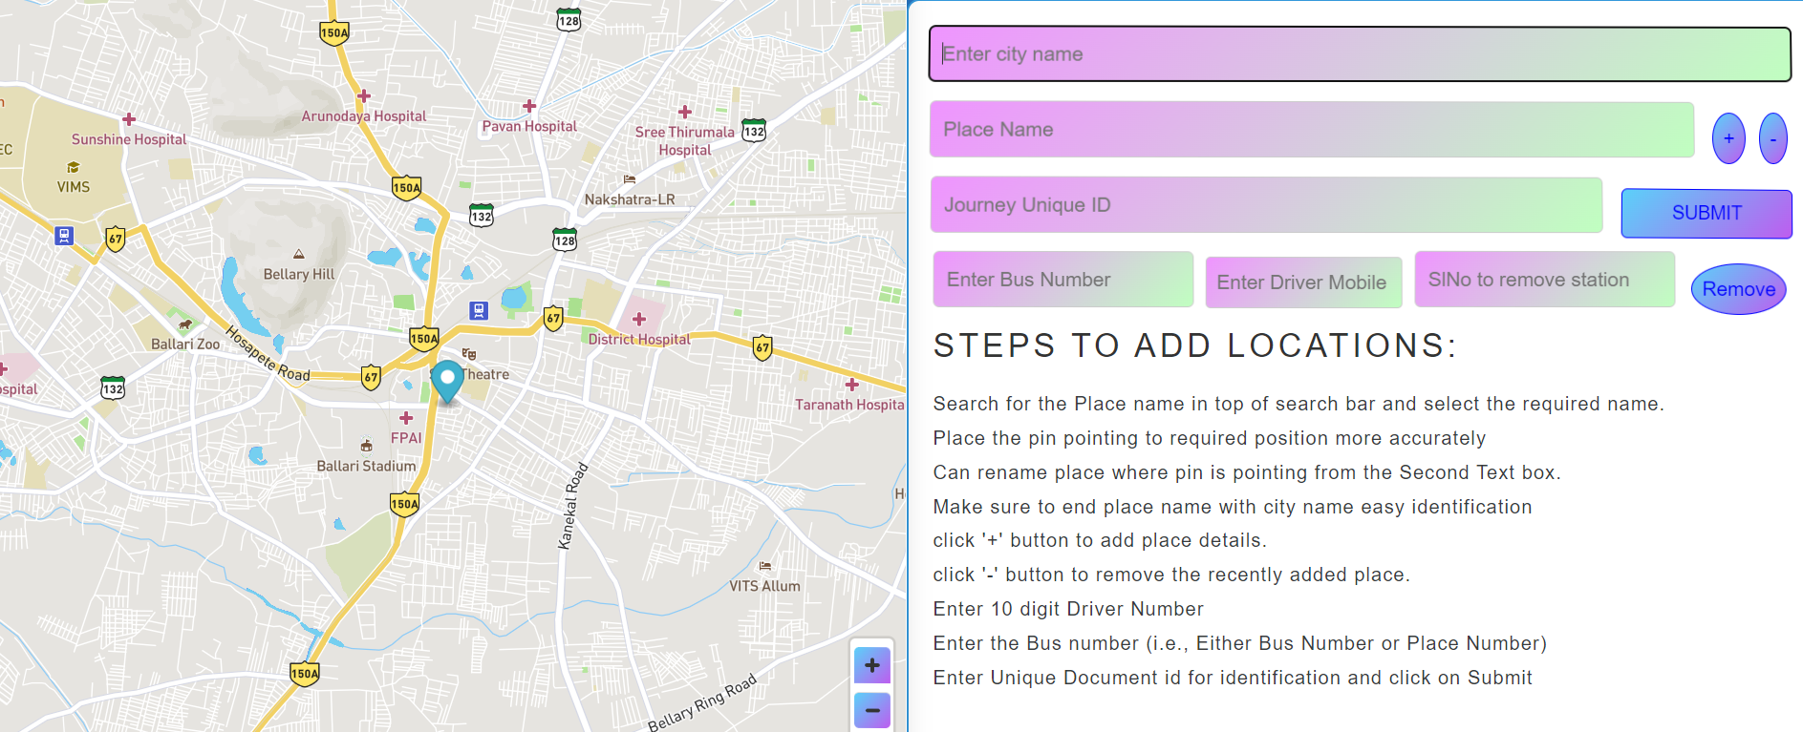

Figure 4: Map Routes

Figure 4 illustrates the Map-Based Routes and Dynamic Data Input Interface tailored for college buses, featuring intelligent place suggestions for enhanced usability and efficiency.

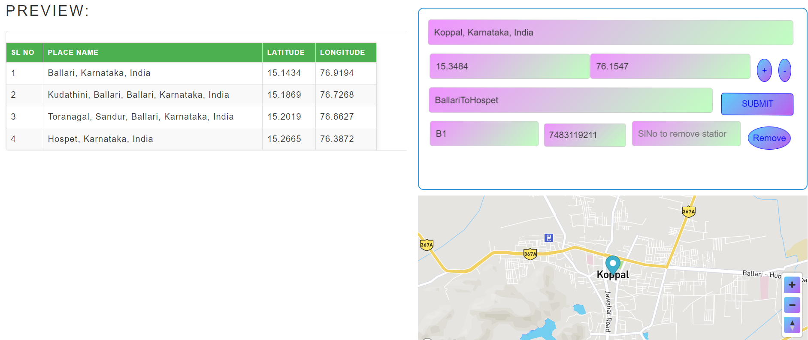

Figure 5: Adding Routes

Figure 5 showcases the Map-Based Routes and Dynamic Data Input Interface designed specifically for public buses, incorporating intuitive place suggestions to streamline the user experience and

improve efficiency.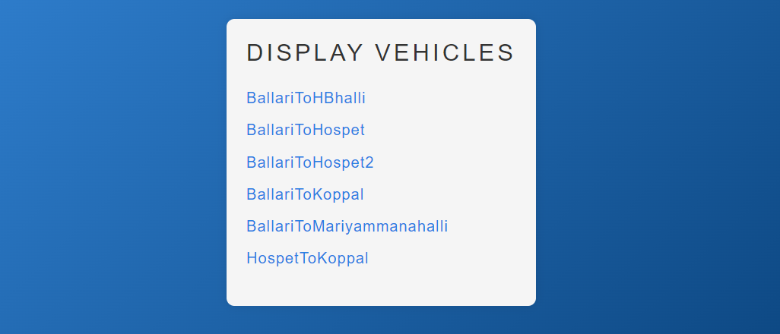

Figure 6: List of Vehicles with Different Routes

Figure 6 depicts the Source to Destination Mapping for Admin-Added Vehicles, providing administrators with a structured overview of each vehicle's journey from its origin to its destination. This feature enables efficient management of the transportation fleet, contributing to system transparency and facilitating informed decision-making processes.

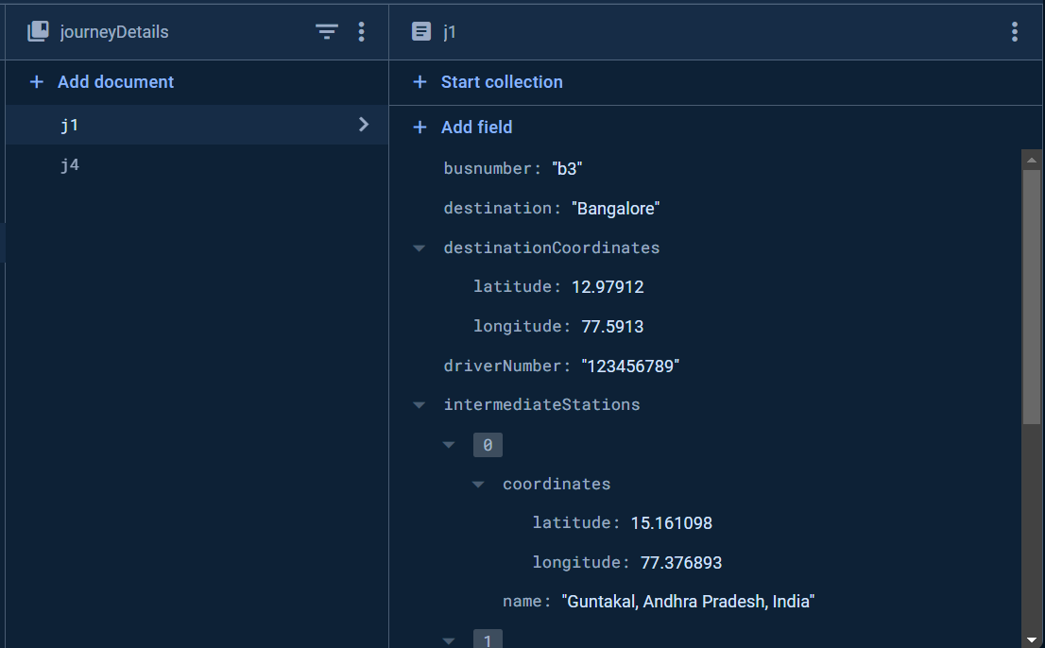

Figure 7: Database of the application

Figure 7 illustrates the Google Fire Store Database utilized for storing and retrieving vehicle, journey, and location information. This database serves as a central repository, enabling efficient management and access to crucial data related to vehicles, journeys, and real-time locations.

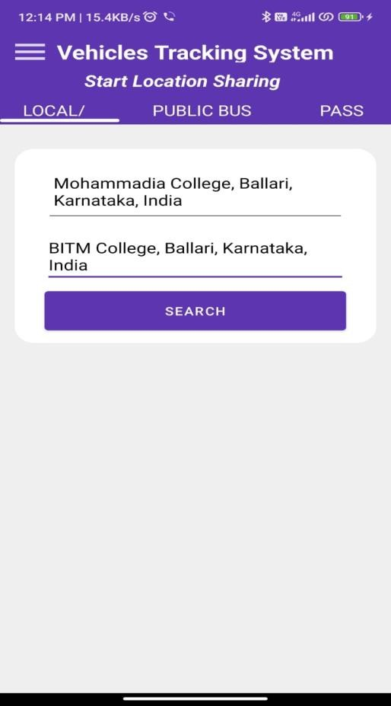

Figure 8: Searching in the app interface

Figure 8 showcases the Home Page of the Android application, providing intuitive search functionality.

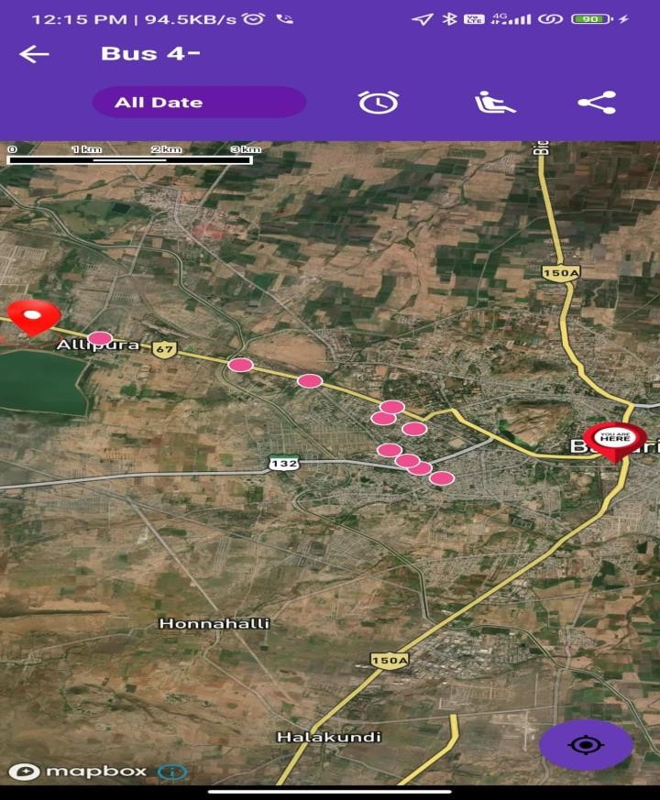

Figure 9: Displaying the Exact location of the Bus

Figure 9 illustrates the location of the selected bus along with the stop nodes.

**SYSTEM AND SOFTWARE REQUIREMENTS:**

The system needs a server for web hosting and a GPS-enabled smartphone. A stable internet is crucial for real-time data sync. Frontend relies on React.js. Database managed via Google Firebase. Mobile apps developed using Android Studio, integrating MapBox API and Firebase Authentication using Java.

**COMPARATIVE ANALYSIS**

Track N Go offers a cost-effective and user-centric real-time bus tracking solution, leveraging mobile phone location data. Its integration of GPS via Map Box API and Firebase for real-time data storage ensures superior accuracy and performance. The system's user-friendly interfaces surpass existing solutions, enhancing productivity. Track N Go's innovative approach aligns with current urban transportation trends, promising scalability and adaptability. Further studies are needed to assess its long-term effectiveness and broader applicability in public transportation management.

**DISCUSSION:**

1. Key Findings: Track N Go revolutionizes bus tracking with mobile phone location data, enhancing urban transit efficiency.

2. Implications: Cost-effective and user-friendly, it democratizes tracking technology and boosts commuter satisfaction.

3. Limitations: Challenges include network issues, scalability concerns, and data privacy considerations.

4. Recommendations: Optimize network infrastructure, strengthen security measures, and collaborate with authorities for broader integration.

5. Impact: Successful deployment at Ballari Institute highlights Track N Go's potential to transform urban transportation, offering accuracy and scalability for diverse transit needs.

**QUALITATIVE AND QUANTITATIVE ANALYSIS:**

Track N Go sets a new standard in real-time bus tracking, surpassing existing solutions quantitatively and qualitatively. Its exceptional accuracy, rapid response time, and scalability ensure efficient tracking and timely updates. The system's intuitive interface, affordability, and security measures enhance user experience, while features like battery efficiency and offline functionality add to its appeal. Through comprehensive evaluation, Track N Go emerges as a pioneering solution, revolutionizing urban transportation management with its efficiency and user-centric approach.

**V. CONCLUSION**

In conclusion, the "Track N Go" system offers a groundbreaking and cost-effective solution for real-time bus tracking and arrival prediction. Leveraging mobile phone location data, a serverless architecture, and cloud-based NoSQL databases, the system ensures accurate tracking and streamlined data management. Its user-friendly web interface enhances accessibility for administrators and commuters. Looking ahead, potential enhancements such as geofencing, environmental monitoring, and route optimization demonstrate the system's commitment to ongoing improvement. While successfully implemented at the Ballari Institute of Technology and Management, the project sets a benchmark for smarter transit systems. Despite its successes, limitations include potential challenges with network connectivity and scalability. The future scope involves further integration with smart city initiatives, enhanced user customization options, and collaboration with local authorities to optimize transit infrastructure and services.

**ACKNOWLEDGEMENT**

The fulfillment derived from the triumphant accomplishment of the research and development of the web application "Track N Go: Innovative Real-Time Bus Tracking and Arrival Prediction for Public and Private Sectors using Firebase" would be inadequate without acknowledging the individuals instrumental in making it a reality. Their guidance, encouragement, and unwavering support added a crowning touch to my endeavors. I express my gratitude and respect to all those who served as a source of inspiration throughout this research. Special appreciation goes to the esteemed guides, Md. Shafiulla, and Abdul Lateef Haroon P. S, for their support and invaluable suggestions that significantly contributed to the successful conclusion of this study. Additionally, heartfelt thanks are extended to R. N. Kulkarni, Head of the Department of CSE, for his coordination and valuable insights, which played a pivotal role in achieving this milestone.

**REFERENCES**

1. R. Liu, "Construction of Embedded Platform Real-Time Target Tracking System Based on Changing Ant Colony Algorithm," 2023 International Conference on Data Science and Network Security (ICDSNS), Tiptur, India, 2023, pp. 1-6, doi: 10.1109/ICDSNS58469.2023.10245130.
2. M. S. Rudramurthy et al., "Real Time Vehicle Tracking System for Smart Cities," 2023 International Conference on Data Science and Network Security (ICDSNS), Tiptur, India, 2023, pp. 1-6, doi: 10.1109/ICDSNS58469.2023.10245776.
3. S. S. P. Naresh, R. Talasu, D. S. S. P. Venkat, S. K. Korada and B. K. Mohanta, "Real Time Vehicle Tracking using YOLO Algorithm," 2023 14th International Conference on Computing Communication and Networking Technologies (ICCCNT), Delhi, India, 2023, pp. 1-5, doi: 10.1109/ICCCNT56998.2023.10307265.
4. R. Vyas, H. Soni and M. Patel, "AI based Real Time Institutional Vehicle Tracking System through Mobile Application," 2023 Second International Conference on Augmented Intelligence and Sustainable Systems (ICAISS), Trichy, India, 2023, pp. 272-276, doi: 10.1109/ICAISS58487.2023.10250502
5. Z. Wang, X. Zhao, H. Tan, X. Zhang and Y. Sun, "Research on Real-time Monitoring and Tracking Method of Ship Trajectory," 2022 International Conference on Applied Physics and Computing (ICAPC), Ottawa, ON, Canada, 2022, pp. 171-174, doi: 10.1109/ICAPC57304.2022.00039.
6. H. Stuckey, L. Escamilla, L. R. Garcia Carrillo and W. Tang, "Real-Time Optical Localization and Tracking of UAV Using Ellipse Detection," in IEEE Embedded Systems Letters, vol. 16, no. 1, pp. 1-4, March 2024, doi: 10.1109/LES.2023.3234871.
7. Y. Zhou, Y. Yang and M. Hecht, "Real-time predication of railway track curvature using gyroscope and GPS sensors," 2023 DGON Inertial Sensors and Systems (ISS), Braunschweig, Germany, 2023, pp. 1-6, doi: 10.1109/ISS58390.2023.10361925.
8. H. Fu, W. Yao, C. Peng and Y. Wang, "Model Predictive Control with Block Matrix for Unmanned Surface Vehicles Trajectory Tracking," 2023 IEEE International Conference on Mechatronics and Automation (ICMA), Harbin, Heilongjiang, China, 2023, pp. 1379-1384, doi: 10.1109/ICMA57826.2023.10215974.

[9] Y. Ozen, O. Ozdemir and N. Bandirmali, "Android based energy aware real time location tracking system," 2015 Seventh International Conference on Ubiquitous and Future Networks, Sapporo, Japan, 2015,

pp. 842 844, doi: 10.1109/ICUFN.2015.7182662.

[10] P. Jyothi and G. Harish, "Design and implementation of real-time vehicle monitoring, tracking and controlling system," 2016 International Conference on Communication and Electronics Systems (ICCES), Coimbatore, India, 2016, pp. 1 4, doi: 10.1109/CESYS.2016.7889814.

[11] S. Anand, A. Johnson, P. Mathikshara and R. Karthik, "Real-time GPS tracking using serverless architecture and ARM processor," 2019 11th International Conference on Communication Systems & Networks (COMSNETS), Bengaluru, India, 2019, pp. 541 543, doi: 10.1109/COMSNETS.2019.8711273.

[12] O. D. Jimoh, L. A. Ajao, O. O. Adeleke and S. S. Kolo, "A Vehicle Tracking System Using Greedy Forwarding Algorithms for Public Transportation in Urban Arterial," in IEEE Access, vol. 8, pp. 191706 191725,2020, doi:10.1109/ACCESS.2020.3031488.

[13] M. S. A. khan, T. Akter, M. M. Y. Hossain, M. S. Hossain, S. Mazumder and M. K. Alam, "Design and Business Modeling of an IoT Based Cost Effective Vehicular Monitoring System for Next Generation SmartVehicle," 2020 IEEE International Women in Engineering (WIE) Conference on Electrical and Computer Engineering (WIECON ECE), Bhubaneswar, India, 2020, pp. 440 443, doi: 10.1109/WIECON ECE52138.2020.9398003.

[14] F. Farzana, M. M. Hossain, M. M. Imtiaze, M. T. Hossain,A. S. M. M. Jameel and S. Islam, "A Real Time Motion Based Fuel Monitoring Technique For Vehicle Tracking Systems," 2020 Emerging Technology in Computing, Communication and Electronics (ETCCE), Bangladesh, 2020, pp. 1 6, doi: 10.1109/ETCCE51779.2020.9350860.

[15] M. A. Hafiizh Nur, S. Hadiyoso, F. B. Belladina, D. N. Ramadan and I. Wijayanto, "Tracking, Arrival Time Estimator, and Passenger Information System on Bus Rapid Transit (BRT)," 2020 8th International Conference on Information and Communication Technology (ICoICT), Yogyakarta, Indonesia, 2020, pp. 1 4, doi: 10.1109/ICoICT49345.2020.9166375.

[16] K. Ammar, M. Jalmoud, A. Boushehri and K. Fakhro, "A Real time School Bus Tracking and Monitoring System," 2019 IEEE 10th Annual Information Technology, Electronics and Mobile Communication Conference (IEMCON), Vancouver, BC, Canada, 2019, pp. 0654 0660, doi: 10.1109/IEMCON.2019.8936199.

[17] S. A. Saad, A. '. B. Hisham, M. H. I. Ishak, M. H. M. Fauzi,M. A. Baharudin and N. H. Idris, "Real time on campus public transportation monitoring system," 2018 IEEE 14th International Colloquium on Signal Processing & Its Applications (CSPA), Penang, Malaysia, 2018, pp. 215 220, doi: 10.1109/CSPA.2018.8368715.

[18] M. S. Alamgir, I. Jahan, N. Aktar and A. N. Ramisa, "Chittagong University Teachers' Bus Tracking System Using Smartphone Application," 2018 4th International Conference on Electrical Engineering and Information & Communication Technology (iCEEiCT), Dhaka, Bangladesh, 2018, pp. 199 203, doi: 10.1109/CEEICT.2018.8628098.

[19] T. Noguchi, Y. C. Ting, M. Yoshida and A. G. Ramonet, "Real time Cooperative Vehicle Tracking in VANETs," 2020 29th International Conference on Computer Communications and Networks (ICCCN), Honolulu, HI, USA, 2020, pp. 1 6, doi: 10.1109/ICCCN49398.2020.9209650.

[20] J. Zhang, T. Chen and Z. Shi, "A Real Time Visual Tracking for Unmanned Aerial Vehicles with Dynamic Window," 2020 China Semiconductor Technology International Conference (CSTIC), Shanghai, China, 2020, pp. 1 3, doi: 10.1109/CSTIC49141.2020.9282552.

**Mohammed Naveed <naveedmohammed687@gmail.com>**



**Fwd: ICDCECE - 2024 Acceptance Notification for Paper ID 1011**

1 message

**muhammed shafiulla** <mdshafi.ise@gmail.com> Sat, Mar 30, 2024 at 7:30 PM

To: [naveedmohammed687@gmail.com](mailto:naveedmohammed687@gmail.com)

---------- Forwarded message ---------

From: **Microsoft CMT** <email@msr-cmt.org>

Date: Sat, 30 Mar, 2024, 18:02

Subject: ICDCECE - 2024 Acceptance Notification for Paper ID 1011

To: MOHAMMED SHAFIULLA <mdshafi.ise@gmail.com>

Cc: <publicationchair@icdcece.in>

Dear Author(s), Congratulations!

We are pleased to inform you that your paper has been Accepted for Oral presentation at the IEEE 3rd

International Conference on Distributed Computing and Electrical Circuits And Electronics (ICDCECE2024) in association with IEEE Bangalore Section during 26 & 27 April 2024 at Ballari Institute of Technology and Management, Ballari, Karnataka, India. The conference proceedings will be submitted to the IEEE Xplore® digital library.

NOTE: During Camera Ready Submission, please address the reviewer comments mentioned at the end of this email Reviewer Comment:

Format the paper strictly according to the conference template available in the conference website.

Do not modify Layout margin & size of the template.

Related work format is not good, use standard conference format.

Provide proper figure number for every figure as Fig. 1, Fig. 2, and Fig.3…etc. Provide callouts for every figure.

Rewrite equations using equation editor or math type tool. Provide proper equation number to every equation. Please read the following guidelines carefully before submitting the final version of paper: Important Notes for Submission Preparation:

1. Please prepare your Camera-ready paper (Word Document + PDF eXpress) by strictly following the guidelines mentioned below:

* The Final Camera Ready Copy should be strictly according to IEEE format given by IEEE Use the A4 size template available at: (Microsoft word) [https://icdcece.in/downloads/ICDCECE%20Conferencetemplate2024.docx](https://icdcece.in/downloads/ICDCECE%20Conference-template2024.docx) or (LaTex) [https://icdcece.in/ICDCECE%20(](https://icdcece.in/ICDCECE%20)2024)%20-%20Conference-latex-template.zip • Do not modify layout margin of the conference template.
* Ensure the Similarity Index (Plagiarism Report) should be less than 30% Including References and any single source of plagiarism should not be more than 5%.
* Maintain minimum 15 references in the paper
* Incorporate the correction suggested by the reviewer.
* Mention affiliations of all the authors
* Mention mail id of all the authors
* Run a Spellcheck and proofread your paper thoroughly to ensure that it contains no typo and grammatical errors
* Include good quality figures/graphics
* Tables must be drawn in text format, not as an image.
* In-text description and callouts for all the figure numbers, table numbers and equation numbers must be present in the paper as per the order of their occurrence
* Citation of all the references must be done inside the paper, that is, in-text citations.
* In-text citations must match their corresponding reference listed under the references section and vice-versa.
* Citation must be in ascending order, not in random manner
* Reference should not be cited in Abstract and Conclusion part.
* Remove words like “Our/we/us” from the paper
* Do not mention Salutations like “Dr./Mr./Mrs./Prof./Research Scholar/Student” in the author details section
* Rename the final camera-ready file (save as .doc/.docx (for Word) or .pdf/.rar (for LaTex)) with the conference name & paper id (For Example “ICDCECEXXXX.docx); Where XXXX is your CMT Submission ID

(Eg: Suppose CMT Paper Id is Paper 1, give XXXX is 0001)

* Camera ready paper is meant ONLY FOR ONE TIME submission. After the submission strictly no more corrections will be entertained.
* Include Header and Footer in your Paper for First Page Only.

Header: 2024 Third International Conference on Distributed Computing and Electrical Circuits and

Electronics (ICDCECE)

Footer: 979-8-3503-1860-9/24/$31.00 ©2024 IEEE

IEEE PDF eXpress

1. Access the IEEE PDF eXpress site at <https://ieee-pdf-express.org/>
2. Login to the portal
3. Conference ID: 60827X
4. (New users need to register; Existing users can use the same login)
5. For each conference paper, click “Create New Title”.
6. Enter identifying text for the paper (title is recommended but not required)
7. Click "Submit PDF for Checking" or "Submit Source Files for Conversion"
8. Indicate platform, source file type (if applicable), click Browse and navigate to file, and

click “Upload File”. You will receive online and email confirmation of successful upload

1. You will receive an email with your Checked PDF or IEEE PDF eXpress-converted PDF attached. If you submitted a PDF for Checking, the email will show if your file passed or failed. The PDF file must pass the compatibility test in the IEEE PDF eXpressTM for submitting your paper to IEEE Digital Xplore, so repeat the process until it is passed.

2. Guideline to register yourself in ICDCECE 2024

The Camera Ready papers should be drafted in English with a maximum of Eight (8) pages and minimum of 4 pages including figures, tables and references. Kindly visit following website for registration fee and extra page charges.

Registration Fee Details: [https://icdceeece.in/registration](https://icdcece.in/registration.php)

Step 1 The payment of registration fee shall be made through Internet banking NEFT/IMPS/RTGS.

Bank account details

Account Number: 10977101024159

Account Name: IEEE Student Branch BITM

Type of account: Current account

Name of the Bank: Pragathi Krishna Gramin Bank

IFSC: PKGB0010977

Step 2

After successful transaction please visit following registration link to register yourself for the conference. Please make sure that corresponding paper ID, Transaction proof (Image), Final Camera Ready Paper (.doc/.docx/LaTex), PDF eXpress Compatible Final Camera ready paper (PDF) and PDF eXpress Paper id should be uploaded during registration.

Registration and final paper submission link: <https://forms.gle/oBdqHYxekq48AnzTA>

1. If you have any doubts, please contact: publicationchair@icdcece.in
2. An accepted paper will be submitted in the IEEE Xplore® digital library only if the final version is accompanied by the registration and payment information for at least one of the authors.

--------------------------------------------------------------------------------------------------------------------

** Deadline for Camera-ready paper (.docx file), Registration/Payment Proof submission: 31st March 2024**

Thanks for your understanding and cooperation.

---------

Thanks, and regards

Organizing Committee

ICDCECE-2024

To stop receiving conference emails, you can check the 'Do not send me conference email' box from your User Profile.

Microsoft respects your privacy. To learn more, please read our [Privacy Statement.](https://go.microsoft.com/fwlink/?LinkId=521839)

Microsoft Corporation One [Microsoft Way](https://www.google.com/maps/search/Microsoft+Way+Redmond,+WA+98052?entry=gmail&source=g)

[Redmond, WA 98052](https://www.google.com/maps/search/Microsoft+Way+Redmond,+WA+98052?entry=gmail&source=g)



**BALLARI INSITUTE OF TECHNOLOGY AND MANGEMENT, BALLARI**



**DEPARTMENT OF COMPUTER SCIENCE & ENGINEERING**

**Project CO-PO Mapping ACADEMIC YEAR 2022-23**

**COURSE OUTCOME(CO’S)**

|  |  |
| --- | --- |
| **COURSE OUTCOME STATEMENT** | |
| **CO-1** | Identify the real-world problem related to Bus arrival time. |
| **CO-2** | Analyzing how to Track Vehicles in real time without IoT Devices and come up with an engineering solution. |
| **CO-3** | Design An Innovative approach to solve the problem associated with ETA and Bus Tracking. |
| **CO-4** | Implementing Web application tools/technologies like React and Android applications using Java to create a Virtual environment. |
| **CO-5** | Write technical project report and publish the thesis in a conference. |

**CO-PO MAPPING**

|  |  |  |  |  |  |  |  |  |  |  |  |  |  |  |
| --- | --- | --- | --- | --- | --- | --- | --- | --- | --- | --- | --- | --- | --- | --- |
| **CO-PO Mapping** | | | | | | | | | | | | | |  |
|  | **PO-1** | **PO-2** | **PO-3** | **PO-4** | **PO-5** | **PO-6** | **PO-7** | **PO-8** | **PO-9** | **PO-10** | **PO-11** | **PO-12** | **PSO-1** | **PSO-2** |
| **CO-1** | 2 |  |  |  |  |  |  | 3 |  |  |  |  |  |  |
| **CO-2** |  | 3 |  | 2 |  |  |  |  |  |  |  |  |  |  |
| **CO-3** |  |  | 3 |  | 3 |  |  |  |  |  |  |  |  |  |
| **CO-4** |  |  | 3 |  | 3 |  |  |  |  |  |  |  |  | 3 |
| **CO-5** |  |  |  |  |  |  |  |  | 2 | 2 | 2 |  |  |  |
| **Avg.**  **Mapping Value** | **2** | **3** | **3** | **2** | **3** | **0** | **0** | **3** | **2** | **2** | **2** | **0** | **0** | **3** |

Signature of Guide

### PROGRAM OUTCOMES AND PROGRAM SPECIFIC OUTCOMES

|  |
| --- |
| **PO1. Engineering knowledge**: Apply the knowledge of mathematics, science, engineering fundamentals, and an engineering specialization to the solution of complex engineering problems.  **PO2. Problem analysis**: Identify, formulate, review research literature, and analyze complex engineering problems reaching substantiated conclusions using first principles of mathematics, natural sciences, and engineering sciences.  **PO3. Design/development of solutions**: Design solutions for complex engineering problems and design system components or processes that meet the specified needs with appropriate consideration for the public health and safety, and the cultural, societal, and environmental considerations.  **PO4. Conduct investigations of complex problems**: Use research-based knowledge and research methods including design of experiments, analysis and interpretation of data, and synthesis of the information to provide valid conclusions.  **PO5. Modern tool usage**: Create, select, and apply appropriate techniques, resources, and modern engineering and IT tools including prediction and modeling to complex engineering activities with an understanding of the limitations.  **PO6. The engineer and society**: Apply reasoning informed by the contextual knowledge to assess societal, health, safety, legal and cultural issues and the consequent responsibilities relevant to the professional engineering practice.  **PO7. Environment and sustainability**: Understand the impact of the professional engineering solutions in societal and environmental contexts, and demonstrate the knowledge of, and need for sustainable development.  **PO8. Ethics**: Apply ethical principles and commit to professional ethics and responsibilities and norms of the engineering practice.  **PO9. Individual and team work**: Function effectively as an individual, and as a member or leader in diverse teams, and in multidisciplinary settings.  **PO10. Communication**: Communicate effectively on complex engineering activities with the engineering community and with society at large, such as, being able to comprehend and write effective reports and design documentation, make effective presentations, and give and receive clear instructions.  **PO11. Project management and finance**: Demonstrate knowledge and understanding of the engineering and management principles and apply these to one’s own work, as a member and leader in ateam, to manage projects and in multidisciplinary environments.  **PO12. Life-long learning**: Recognize the need for, and have the preparation and ability to engage in independent and life-long learning in the broadest context of technological change. |
| **PSO1.** Understand the principles, architecture, and organization of computers, embedded systems, and computer networks  **PSO2.** To develop software applications using advanced technologies to cater the growing needs of industry. |

**Project Guide**



### Project Associates









Name: Mr. Mohammed Shafiulla Email: [mdshafi@bitm.edu.in](mailto:mdshafi@bitm.edu.in) Phone no: 8880770638

Name: Shaik Mohammed Naveed USN: 3BR20CS155

Emai: [naveedmohammed687@gmail.com](mailto:naveedmohammed687@gmail.com)

Phone no: 7483119211.

Name: Suhail Ahmed

USN: 3BR20CS163

Email: suhailcmmb@gmail.com

Phone no: 9731400328.

Name: Mahika Dhar M

USN: 3BR20CS096

Email: mahikadhar1@gmail.com

Phone no: 9481321657.

Name: Utkarsh Kumar

USN: 3BR20CS173

Email: utkarsh25062001@gmail.com

Phone no: 9798461659.